## Background Information

### Maternal Mortality

In 2015, the United Nations committed to the achievement of 17 Sustainable Development Goals (SDGs) by 2030 [1]. These SDGs targeted health, the environment, inequality, peace and justice with the aim of eliminating global poverty and protecting the planet [1]. Progress towards the Sustainable Development Goals is monitored by a panel of independent scientists [1]. In 2023, this panel produced a report warning the international community that many of these goals would fail to be met given the current level of progress and a combination of crises that further stalled and/or wiped away years of progress, such as the COVID-19 pandemic and environmental disasters [1].

The report emphasised the need to increase the pace at which maternal and child mortality is being targeted and eliminated [1]. In response to these concerns, in 2024 an additional resolution was passed at the Seventy-seventh World Health Assembly in 2024 to increase progress and further reduce maternal and child mortality [3]. SDG 3.1 was one of the main goals targeted by this resolution, where goal 3.1 aims to reduce the global maternal mortality ratio to below 70 per 100 000 live births by 2030 [3]. The World Health Organisation defines that maternal mortality ratio (MMR) as [3]:

“the number of maternal deaths in a given time period per 100 000 live births during the same time period”

Where the latest version of the International statistical classification of diseases and related health problems (ICD) defines a maternal death as [2]:

“the death of a woman while pregnant or within 42 days of termination of pregnancy, irrespective of the duration and site of the pregnancy, from any cause related to or aggravated by the pregnancy or its management, but not from accidental or incidental causes.”

These concerns were driven from the analysis that, despite falling by 40.0% between 2000 and 2023, as of 2023, the global MMR was 197 deaths per 100,000 live births (uncertainty interval 174 to 234), notably higher than the SDG goal of 70 deaths per 100,000 live births [3]. However, these global statistics hide country-level inequity, as approximately 95% of maternal deaths occur in low and lower middle-income countries and fragile settings [4]. For example, while Nigeria had an MMR of 993 in 2023 (uncertainty interval 718 to 1540), Australia had an MMR of 2 (uncertainty interval 2 to 4) in the same year [3]. As a result, only a small subset of countries is projected to meet this SDG [4].

The leading cause of maternal deaths between 2009 and 2020 was haemorrhage (27%) [4]. Studies have found that haemorrhage disproportionately causes maternal death among women in lower-middle income countries [4]. Many of these maternal deaths are considered preventable, as effective treatments have been developed to prevent haemorrhage induced maternal death [4]. Indirect obstetric deaths (23%) and hypertensive disorders (16%) were the second and third most common causes of maternal death between 2009 and 2020, followed by abortion and pregnancy-related infection (7%) [4].

### Monitoring Maternal Mortality

**Say what sources are normally used to monitor it**

The maternal mortality ratio (MMR) is typically estimated from one or more of a diverse range of data sources. More specifically, MMR estimates are typically informed by national civil registration and vital statistics (CRVS) systems, which are country-specific data collection systems that continuously record births and medically certified deaths within a country [3, Peterson et al., 2024]. The data recorded in these systems is mandated by country-specific legislation [10]. Deaths are recorded with their associated cause of death in line with the International statistical classification of diseases and related health problems (ICD) [3, Peterson et al., 2024]. Thus, CRVS systems generate vital information for mortality monitoring and policy development, as in a perfect world they would record all deaths occurring within a country with their causes [10, 11]. However, these systems are limited by their national coverage and the quality of data recorded in them [10]. Many studies have identified that maternal deaths are unreported and/or misclassified [Peterson et al., 2024; 4]. Given the relative rarity of maternal mortality events, a large sample size and/or complete records are required to produce stable MMR estimates [Peterson et al., 2024]. For example, in 2017, less than 40% of countries have civil registration systems that allow them to continuously and accurately monitor maternal mortality [10]. Unfortunately, this prevents accurate monitoring of trends in maternal mortality, especially in the lowest income countries that have the highest MMR burdens, as they tend to have the most missing data [3; 4; Peterson et al., 2024]. More explicitly, in 2017, of the 49 least developed countries, only 2 have greater than 50% death registration coverage [10].

CRVS systems also underestimate maternal mortality due to misclassification errors, where the incorrect cause of death is recorded in the CRVS database [ 11]. As a more explicit example, a study run in Guatemala found that adding data from medical charts and public healthcare centres to the country’s CRVS data increased the number of maternal deaths by a factor of three compared to the CRVS data alone [10]. Due to underreporting and misclassification errors, reliability of CRVS data must be confirmed before use [3].

MMR estimates are also informed by specialised studies on maternal mortality, whose goal is to determine the true MMR within a specific geographic region. These studies use data from information sources like police and medical records, national registries, administrative reviews, medical autopsies, and censuses [3].

In addition to CRVS systems and specialised studies, the MMR can also be informed by broader surveys, censuses, and national surveillance data, which include both national surveys and Multiple Indicator Cluster Surveys (MICS), which use the sisterhood method to better understand the incidence of maternal deaths in a population [3]. However, despite this diverse range of data sources, it is difficult to estimate accurate MMR values due to missing data and/or errors in the collected data [Peterson et al., 2024].

**Say limitations of these sources**

While maternal mortality is underreported at all stages of pregnancy, this is particularly true at the earliest stages of pregnancy when death may be due to abortion-related complications and/or indirect causes like malaria [Peterson et al., 2024]. Maternal mortality is often also misclassified because of the complexity of isolating the underlying cause [Peterson et al., 2024].

Reports published by the World Health Organisation (WHO) as well as academic researchers highlight how lack of access to accurate, complete data about maternal mortality hinders effective interventions [3,4]. For example, in 2015 the WHO highlighted the necessity of improving measurement of maternal mortality in its Strategies toward Ending Maternal Mortality report [4]. Maternal mortality data helps policymakers identify high-risk regions as well as possible causes of maternal mortality, thus allowing them to implement targeted, useful programs to reduce maternal mortality [3].

Peterson et al. : <https://www.tandfonline.com/doi/epdf/10.1080/2330443X.2023.2286313?needAccess=true>

**Introduce machine learning as an alternative**

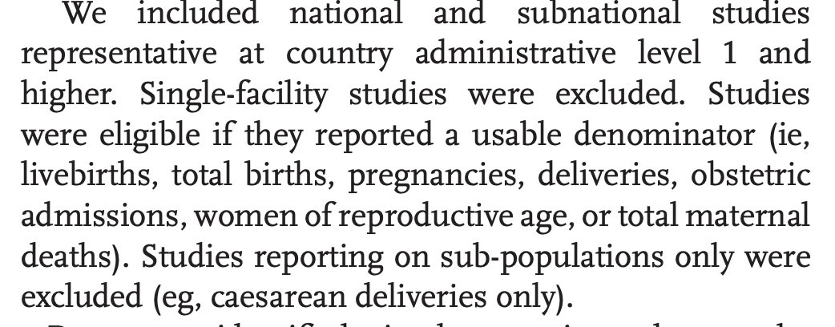 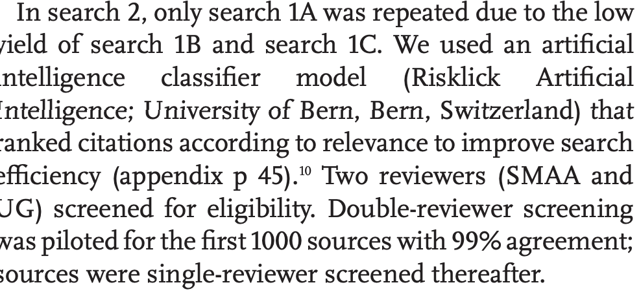

* 4
* Showing how ml is used in public health research

### Machine Learning

1. Machine learning to be able to predict information in data-sparse fields
   1. Say that machine learning has been increasingly used in public health and to predict missing data (then say more on this later in the literature review)

Emerging technologies that enable the collection and transport of large quantities of data have created the opportunity for scientists and researchers to identify complex, insightful patterns in “Big Data” [6]. These patterns are increasingly being detected and analysed using machine learning, which refers to the process of creating a model through learning patterns in data as opposed to encoding of hand-crafted rules [6, 5]. Machine learning is particularly useful when applied to datasets with many datapoints and/or variables, as the technique can find hidden patterns that may be missed by human analysis [5]. Generally, machine learning can be used to make predictions in the absence of empirical data and to gain a better understanding of underlying systems [5]. Thus, it is a useful technology to employ in the landscape of missing maternal mortality data.

Conventionally, the input dataset to a machine learning model consists of a number of observations, where each observation is referred to as a ‘datapoint’ [5]. Each datapoint consists of a certain number of variables, which are referred to as ‘features’ in machine learning. Features with discrete values are called ‘categorical’ and features with continuous numerical values are called ‘continuous’ [5]. For example, if a feature describes ‘risk’ and its values were ‘high’, ‘medium’, or ‘low’, it would be considered categorical. In contrast, if its values were a risk score between 0 and 5, it would be continuous. Generally, each row of the input dataset corresponds to a datapoint, and each feature corresponds to a column.

Machine learning models can be broadly classified as supervised or unsupervised methods [5].

#### Unsupervised Learning

Unsupervised learning models can are used to identify patterns in unlabelled data [5]. Unlabelled data refers to an input dataset where the datapoints are not associated with a specific category or value. The aim of unsupervised learning is to uncover hidden patterns and learn the data’s structure [5]. By not providing labels, the model is not explicitly guided toward learning a specific type of pattern in the data. A common application of unsupervised learning methods is dimensionality reduction, which transforms a dataset with many variables into a dataset with fewer variables while retaining as much of the data’s original variation as possible [5]. The transformed dataset may contain linear and non-linear transformations of the original variables. One widely used dimensionality technique is called principal component analysis and is often applied to be able to visualise a dataset with many variables using only two variables [5].

#### Supervised Learning

In contrast, supervised learning occurs when a model is fit to a labelled dataset, where each input datapoint is associated with one or more output categories or values [5]. These outputs are referred to as the ‘ground truth’, and the model is trained to recognise patterns to help it predict the ground truth [5]. Supervised learning can be applied to classification problems, where the ground truth is one or more specific categories, or regression problems, where the ground truth is a continuous numerical output [5]. This thesis will focus on supervised machine learning methods for regression analysis, as models can be trained on data labelled with ground truth maternal mortality ratio, which are continuous values.

Conventionally, input data is denoted by *x*, and the associated ground truth is denoted by *y* [6]. When solving a regression problem, the model’s goal is to learn a mapping, *f(x)*, between the input data and the associated ground truth so that, for a new input datapoint, *x\**, the model can correctly predict the associated ground truth *y\** [6]. The type of mapping used defines the machine learning model being implemented [6]. At its core, this mapping is a mathematical function defined by a series of parameters that takes in the input dataset and generates its prediction of the output [5]. The model’s performance is defined by a loss function, which quantifies the difference between the model’s output and the ground truth label [5].

* Loss functions definition

7:

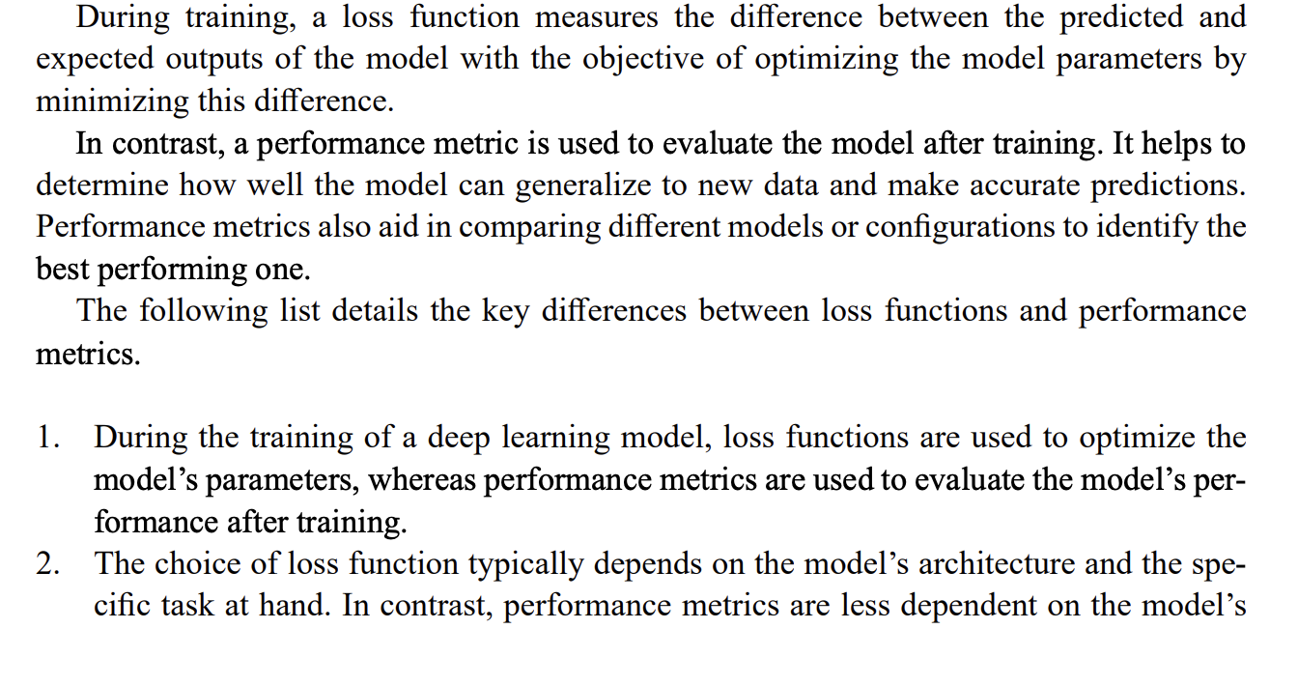

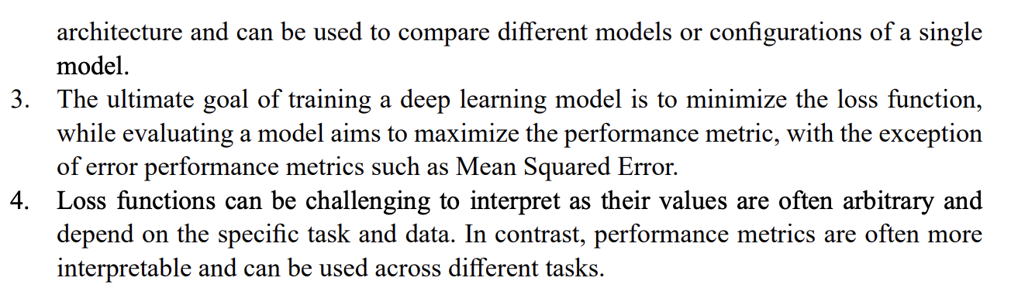 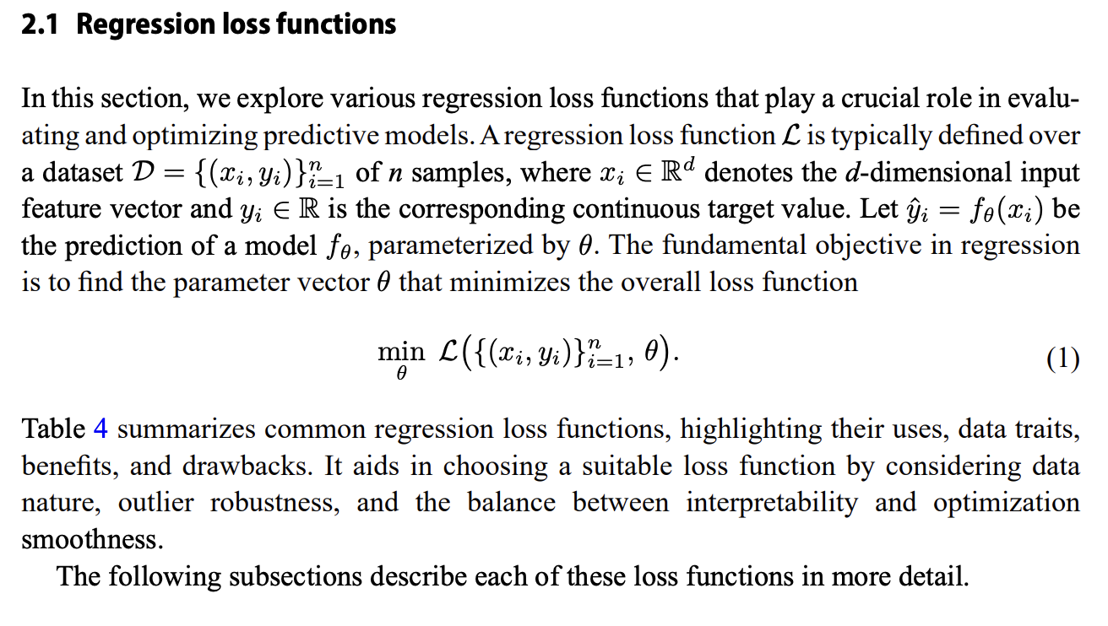 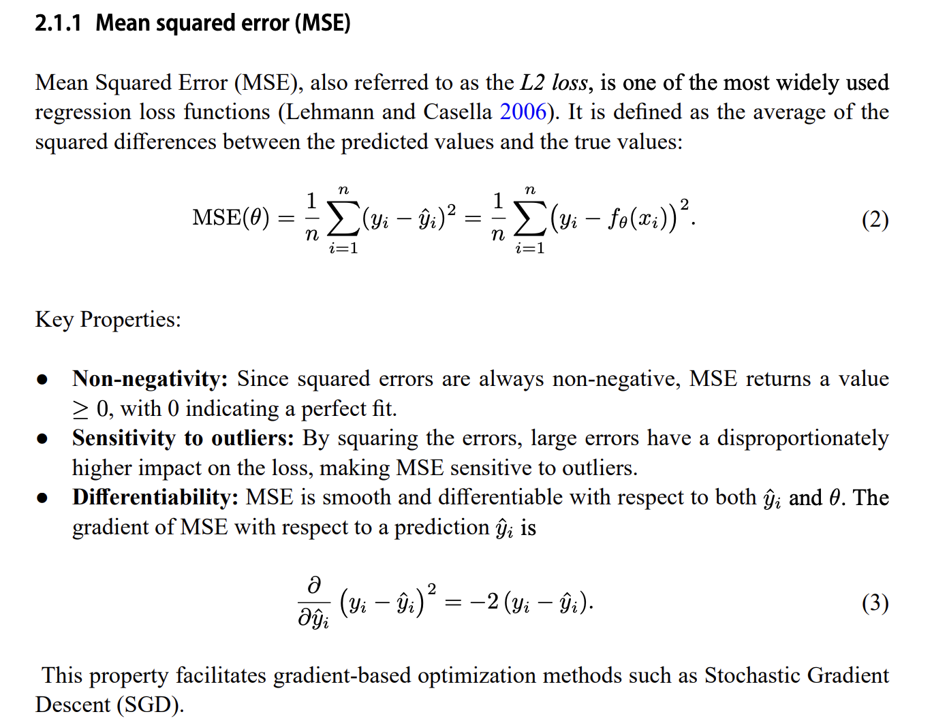 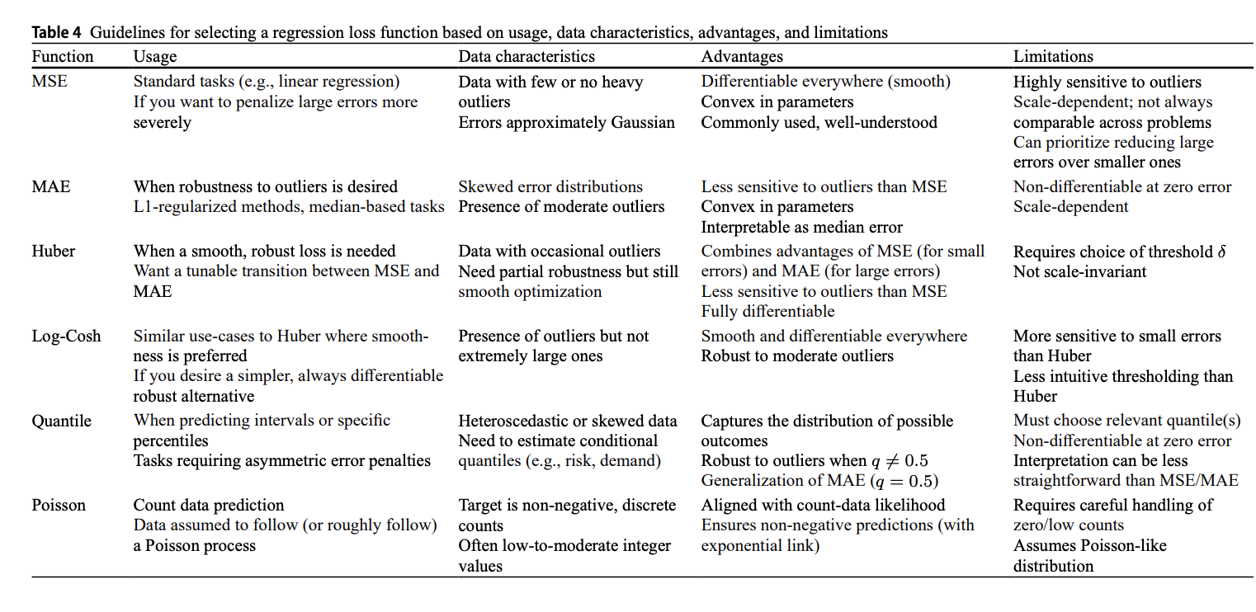 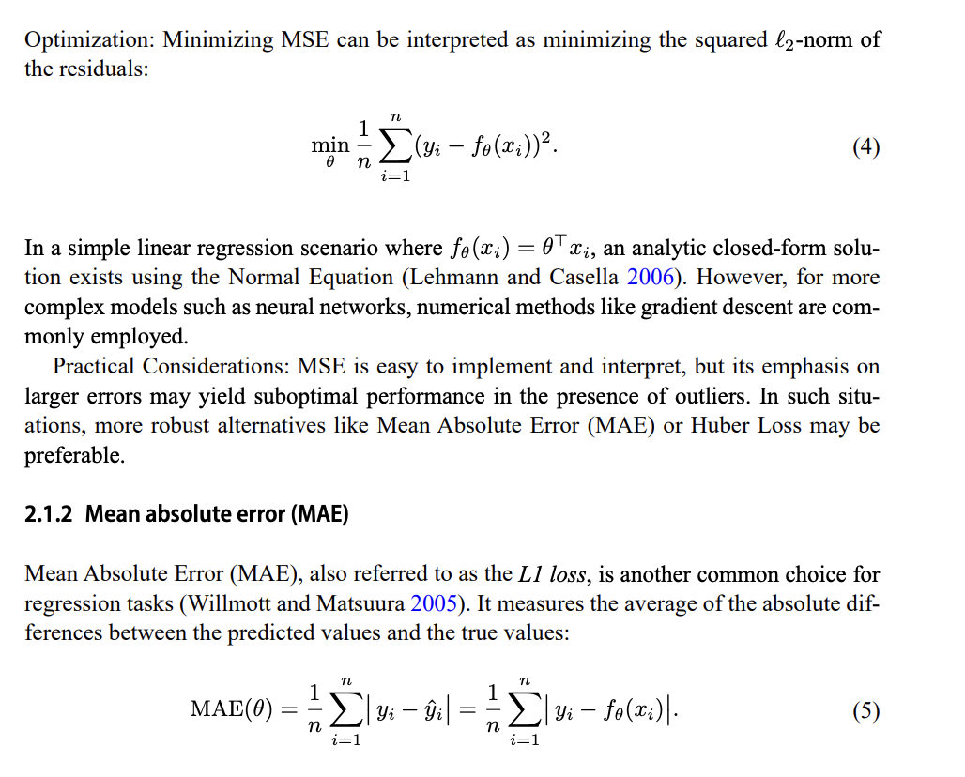 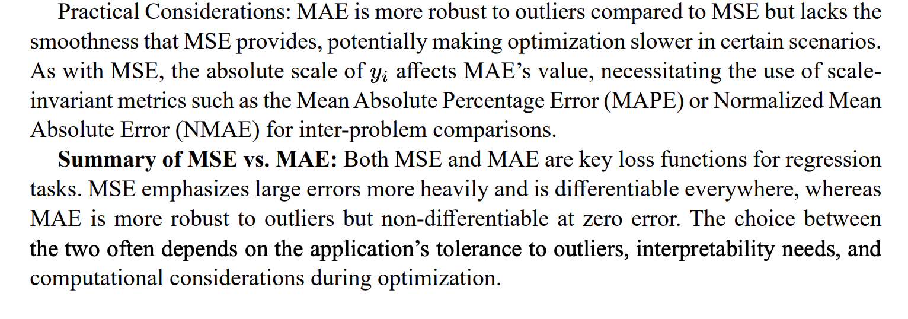 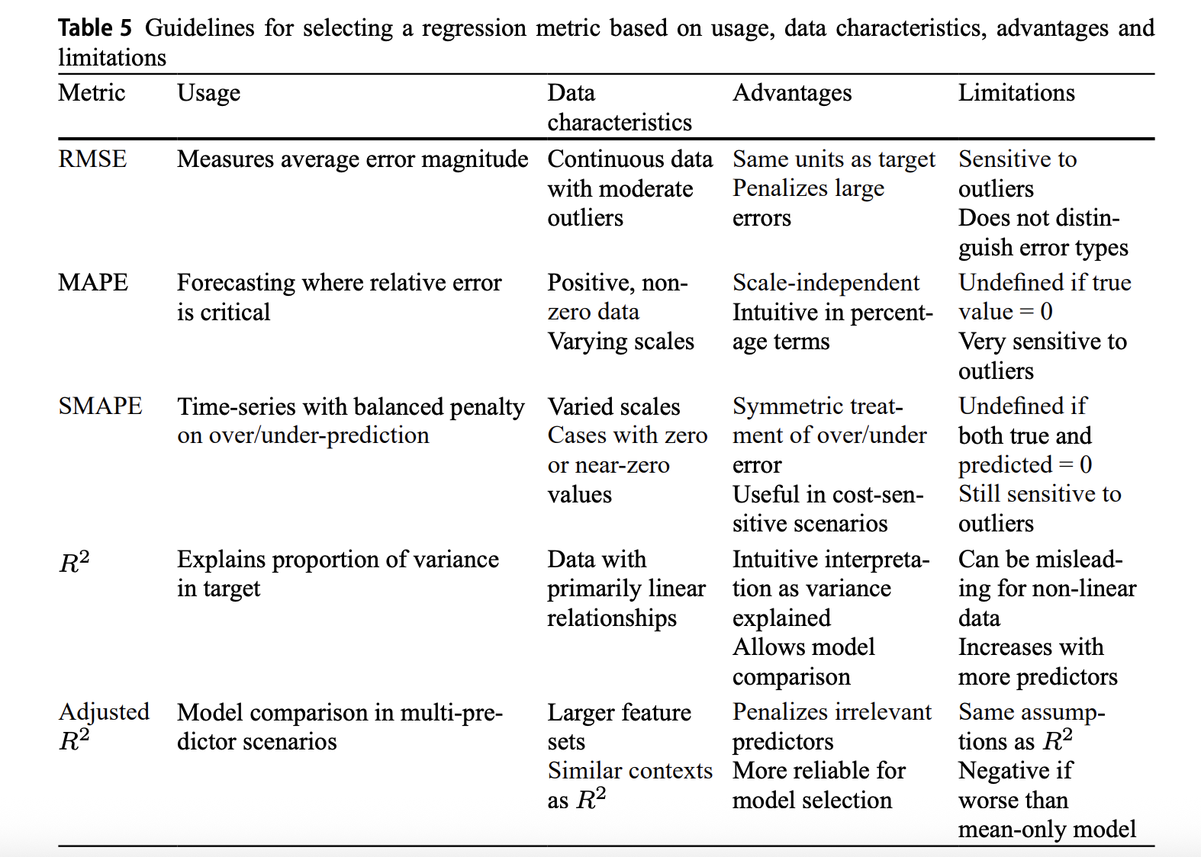 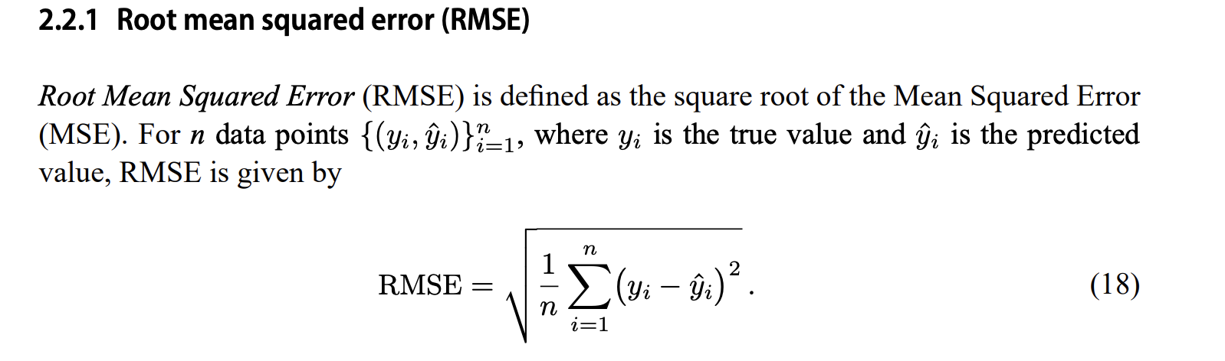 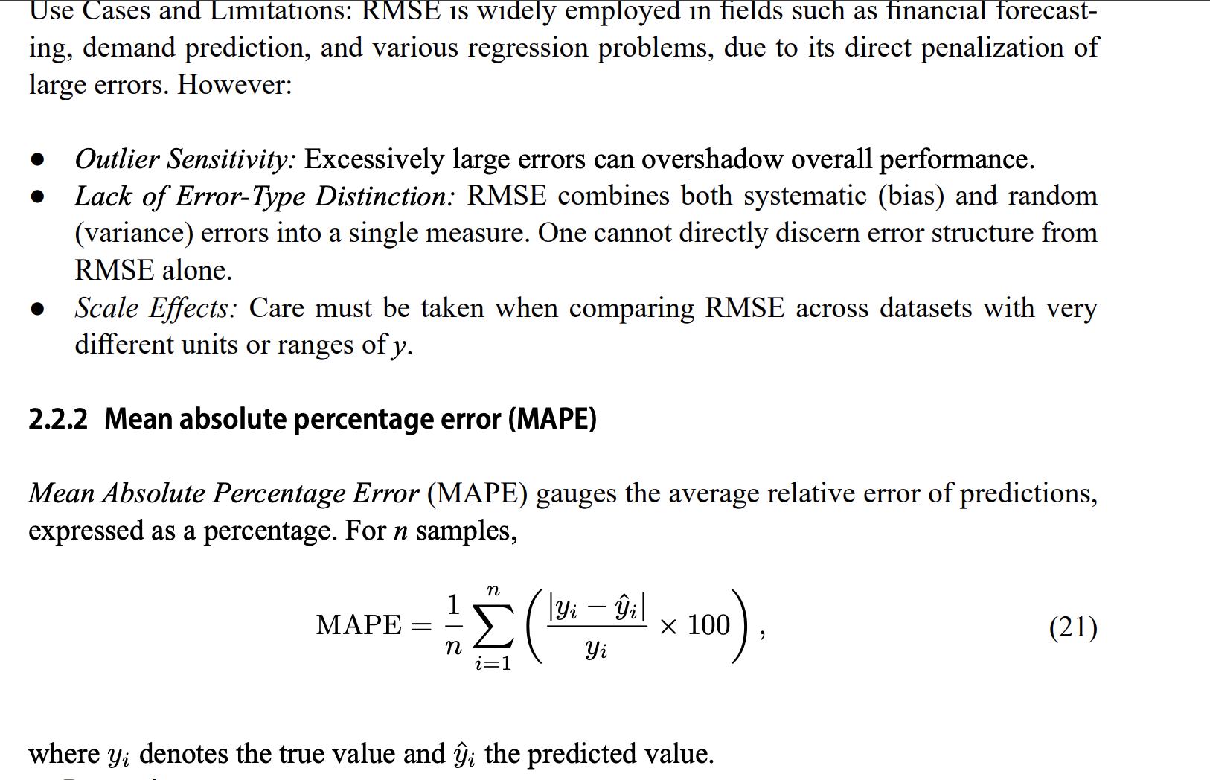 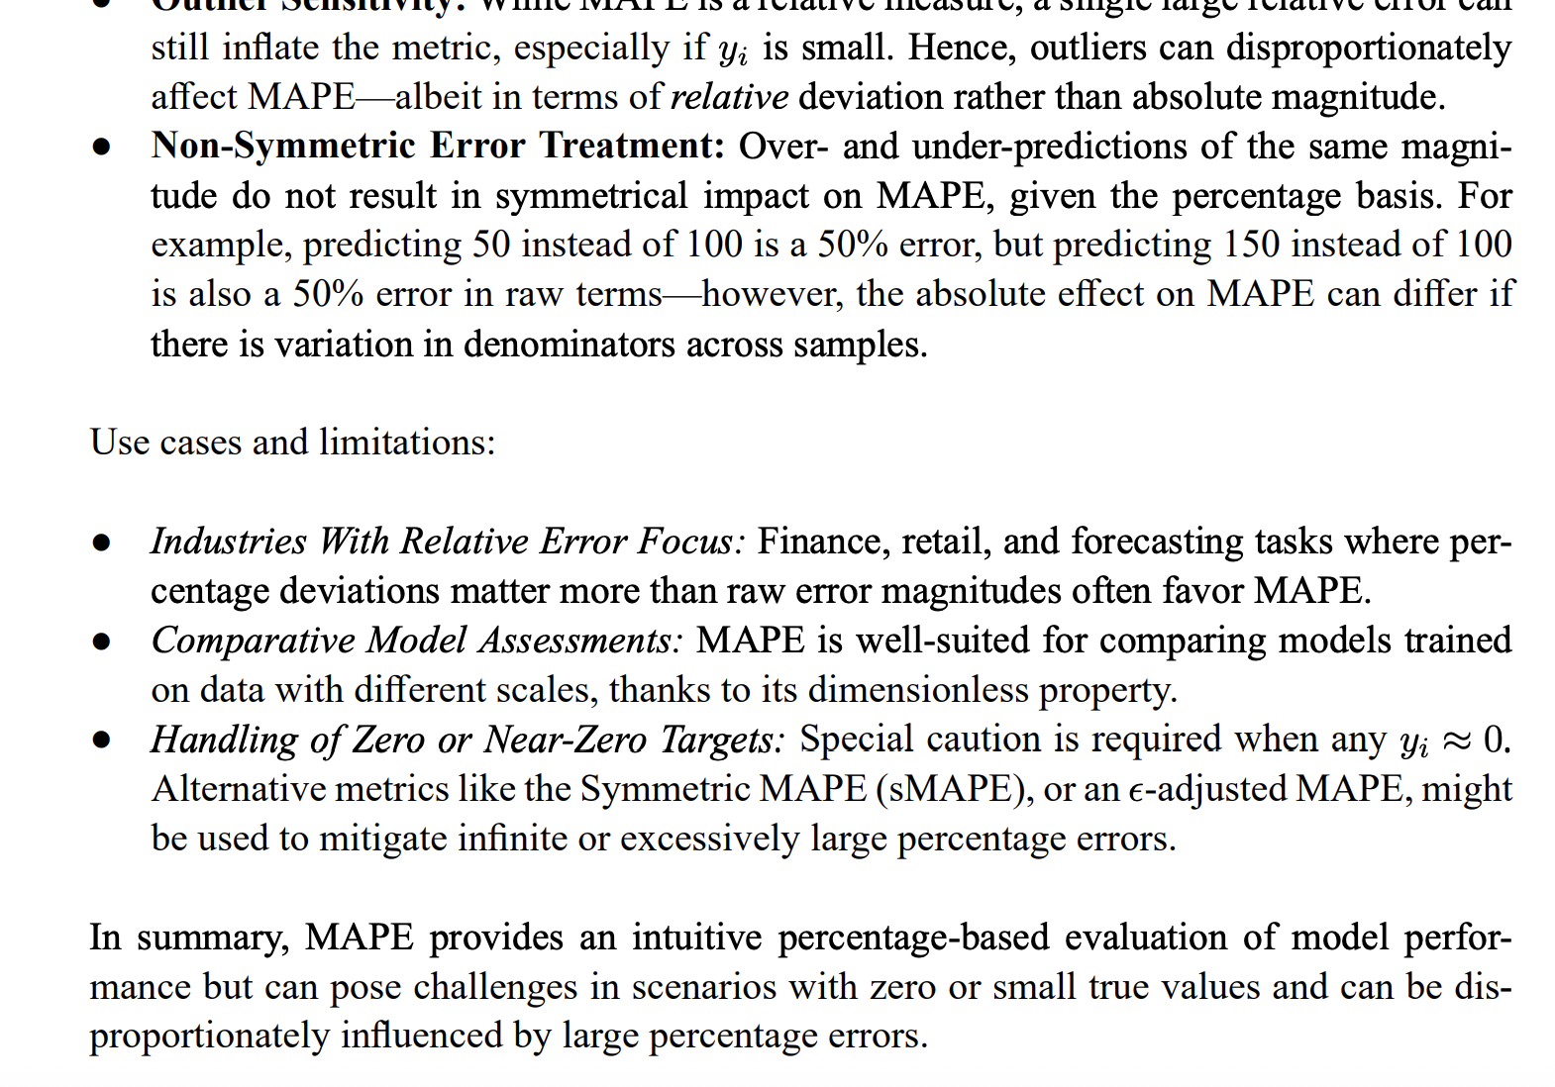 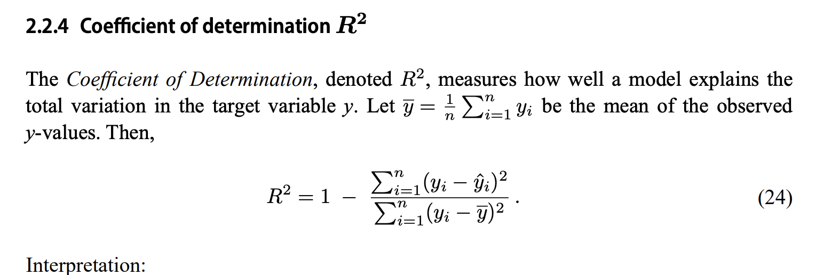 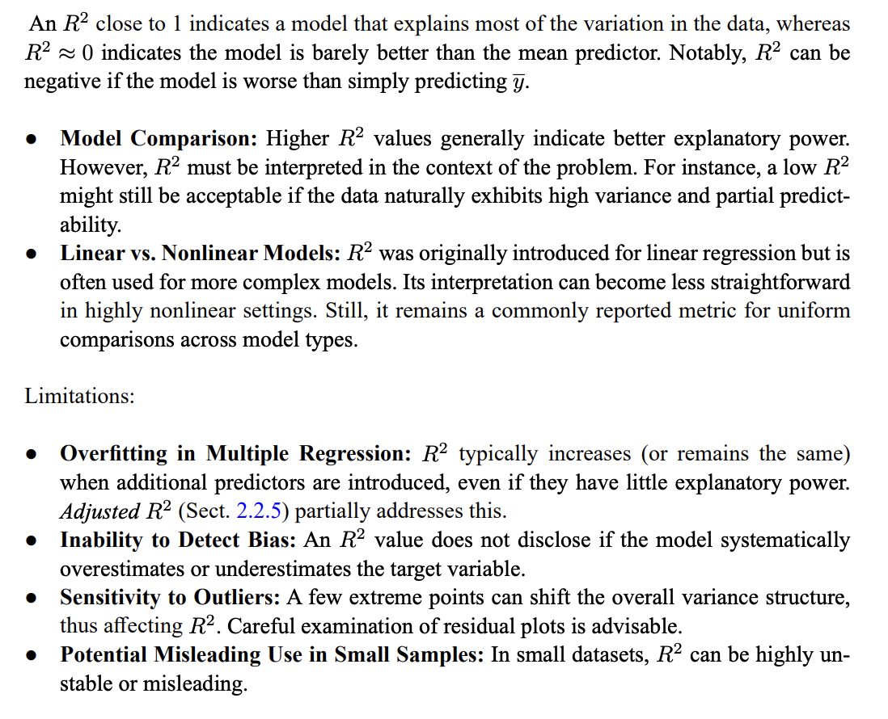

The model’s parameters are finetuned to improve the model’s performance [5].

* Two sets of parameters
* In a simple regression model, for example, each feature has a parameter that is multiplied by the feature value, and these are added together to make the prediction. Hyperparameters are adjustable values that are not considered part of the model itself in that they are not updated during training, but which still have an impact on the training of the model and its performance. A common example of a hyperparameter is the learning rate, which controls the rate or speed with which the model’s parameters are altered during training
* Training, validation and testing. Before being used to make predictions, models require training, which involves automatically adjusting the parameters of a model to improve its performance. In a supervised learning setting, this involves modifying the parameters so the model performs well on a training dataset, by minimizing the average value of the loss or cost function (described earlier). Usually, a separate validation dataset is used to monitor but not influence the training process so as to detect potential overfitting (see the next section). In unsupervised settings, a cost function is still minimized, although it does not operate on ground truth outputs. Once a model is trained, it can be tested on data not used for training. See Box 1 for a guide to the overall process of training and how to split the data appropriately between training and testing sets. A flowchart to help the overall process is shown in Fig. 1, and some of the concepts in model training are shown in Fig. 2
  + Next, the data should be split to allow training, validation and testing. There are a number of ways to do this, two of which are shown in Fig. 2a. The training set is used to directly update the parameters of the model being trained. The validation set, usually around 10% of the available data, is used to monitor training, select hyperparameters and prevent the model overfitting to the training data. Often k-fold cross-validation is used: the training set is split into k evenly sized partitions (for example, five or ten) to form k different training and validation sets, and the performance is compared across each partition to select the best hyperparameters. The test set, sometimes called the ‘hold-out set’, typically also around 10% of the available data, is used to assess the performance of the model on data not used for training or validation (that is, estimate its expected real-world performance). The test set should be used only once, at the very end of the study, or as infrequently as possible27,38 to avoid tuning the model to fit the test set. See the section Data leakage for issues to consider when making a fair test set. The next step is model selection, which depends on the nature of the data and the prediction task, and is summarized in Fig. 1. The training set is used to train the model following best practices of the software framework being used. Most methods have a handful of hyperparameters that need to be tuned to achieve the best performance. This can be done using random search or grid search, and can be combined with k-fold cross-validation as outlined above27. Model ensembling should be considered, where the outputs of a number of similar models are simply averaged to give a relatively reliable way to boost overall accuracy of the modelling task. Finally, the accuracy of the model on the test set (see above) should be assessed.
* Overfitting and underfitting. The purpose of fitting a model to training data is to capture the ‘true’ relationship between the variables in the data, such that the model has predictive power on unseen (non-training) data. Models that are either overfitted or underfitted will produce poor predictions on data not in the training set (Fig. 2d). An overfitted model will produce excellent results on data in the training set (usually as a result of having too many parameters), but will produce poor results on unseen data. The overfitted model in Fig. 2d passes exactly through every training point, and so its prediction error on the training set will be zero. However, it is evident that this model has ‘memorized’ the training data and is unlikely to produce good results on unseen data. By contrast, an underfitted model fails to adequately capture the relationships between the variables in the data. This could be due to an incorrect choice of model type, incomplete or incorrect assumptions about the data, too few parameters in the model and/or an incomplete training process. The underfitted model depicted in Fig. 2d is inadequate for the data it is trying to fit; in this case it is evident that the variables have a non-linear relationship, which cannot be adequately described with a simple linear model and so a non-linear model would be more appropriate.
* Inductive bias and the bias–variance trade-off. The ‘inductive bias’ of a model refers to the set of assumptions made in the learning algorithm that leads it to favour a particular solution to a learning problem over others. It can be thought of as the model’s preference for a particular type of solution to a learning problem over others. This preference is often programmed into the model using its specific mathematical form and/or by using a particular loss function. For example, the inductive bias of recurrent neural networks (RNNs; discussed later) is that there are sequential dependencies in the input data such as the concentration of a metabolite over time. This dependence is explicitly accounted for in the mathematical form of an RNN. Different inductive biases in different model types make them more suitable and usually better performing for specific types of data. Another important concept is the trade-off between bias and variance. A model with a high bias can be said to have stronger constraints on the trained model, whereas a model with low bias makes fewer assumptions about the property being modelled, and can, in theory, model a wide variety of function types. The variance of a model describes how much the trained model changes in response to training it on different training datasets. In general, we desire models with very low bias and low variance, although these objectives are often in conflict as a model with low bias will often learn different signals on different training sets. Controlling the bias–variance trade-off is key to avoiding overfitting or underfitting.

1. Define supervised learning
   * 1. Include information about how data is split into train/val/test sets and evaluated

20:Optuna

* Hyperparameter search is one of the most cumbersome tasks in machine learning projects.
* Define-by-run programming that allows the user to dynamically construct the search space
  + Optuna formulates the hyperparameter optimization as a process of minimizing/maximizing an objective function that takes a set of hyperparameters as an input and returns its (validation) score
  + his function dynamically constructs the search space of neural network architecture (the number of layers and the number of hidden units) without relying on externally defined static variables
  + , a hyperparameter is statistically sampled based on the history of previously evaluated trials
  + . Again, a complex space of hyperparameters is simply expressed in Optuna. Most notably, in this example, the methods ‘create_model’ and ‘create_optimizer’ are independent of one another, so that we can make changes to each one of them separately. Thus, the user can easily augment this code with other conditional variables and methods for other set of parameters, and make a choice from more diverse pool of models.
* Efficient sampling algorithm and pruning algorithm that allows some user-customization
  + In general, the cost-effectiveness of hyperparameter optimization framework is determined by the efficiency of (1) searching strategy that determines the set of parameters that shall be investigated, and (2) performance estimation strategy that estimates the value of currently investigated parameters from learning curves and determines the set of parameters that shall be discarded.
  + The strategy for the termination of unpromising trials is often referred to as pruning
  + There are generally two types of sampling method: relational sampling that exploits the correlations among the parameters and independent sampling that samples each parameter independently. The independent sampling is not necessarily a naive option, because some sampling algorithms like TPE [3] are known to perform well even without using the parameter correlations, and the cost effectiveness for both relational and independent sampling depends on environment and task. Our Optuna features both, and it can handle various independent sampling methods including TPE as well as relational sampling methods like CMA-ES.
    - Implementing of optimization methods that takes the concurrence relations among the parameters into account is a nontrivial challenge when the search spaces are dynamically constructed. To overcome this challenge, Optuna features an ability to identify trial results that are informative about the concurrence relations. This way, the framework can identify the underlying concurrence relations after some number of independent samplings, and use the inferred concurrence relation to conduct user-selected relational sampling algorithms like CMA-ES [9] and GP-BO [27]. Being an open source software, Optuna also allows the user to use his/her own customized sampling procedure
  + Pruning mechanism in general works in two phases. It (1) periodically monitors the intermediate objective values, and (2) terminates the trial that does not meet the predefined condition.
* Easy-to-setup, versatile architecture that can be deployed for tasks of various types, ranging from light-weight experiments conducted via interactive interfaces to heavy-weight distributed computations.

#### Linear Regression

8:

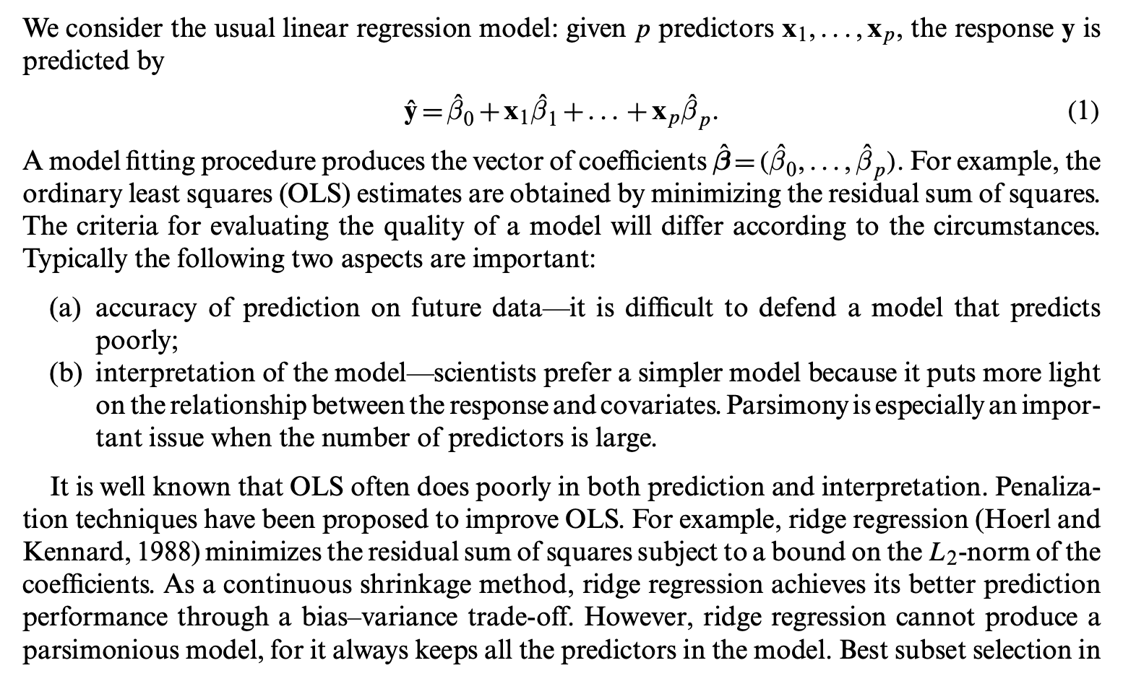 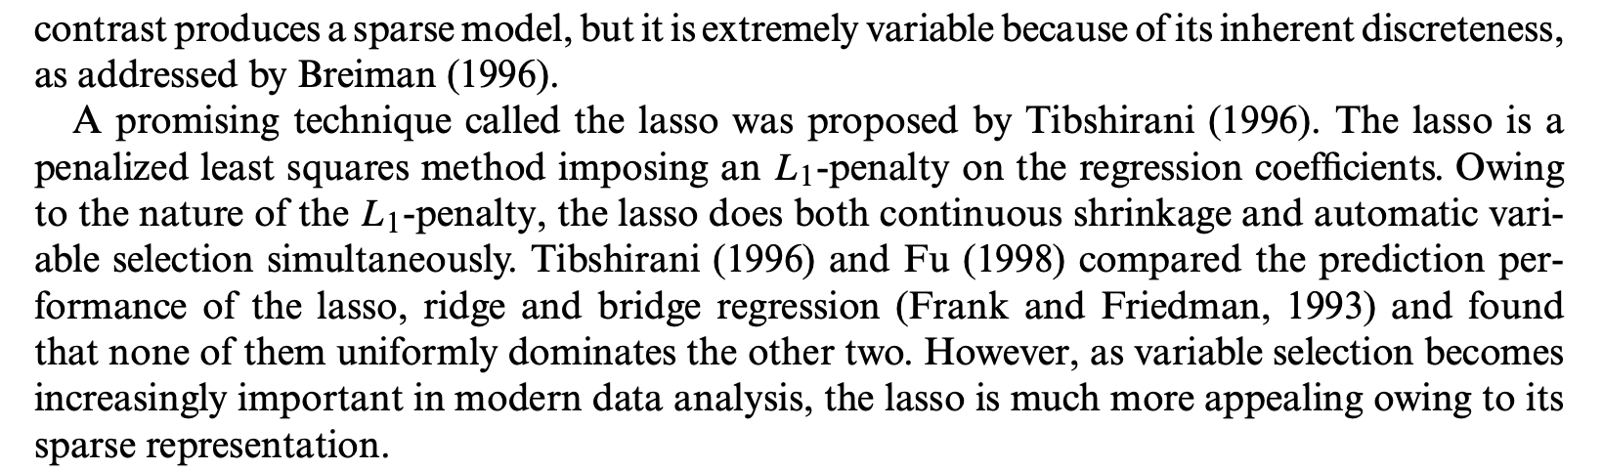 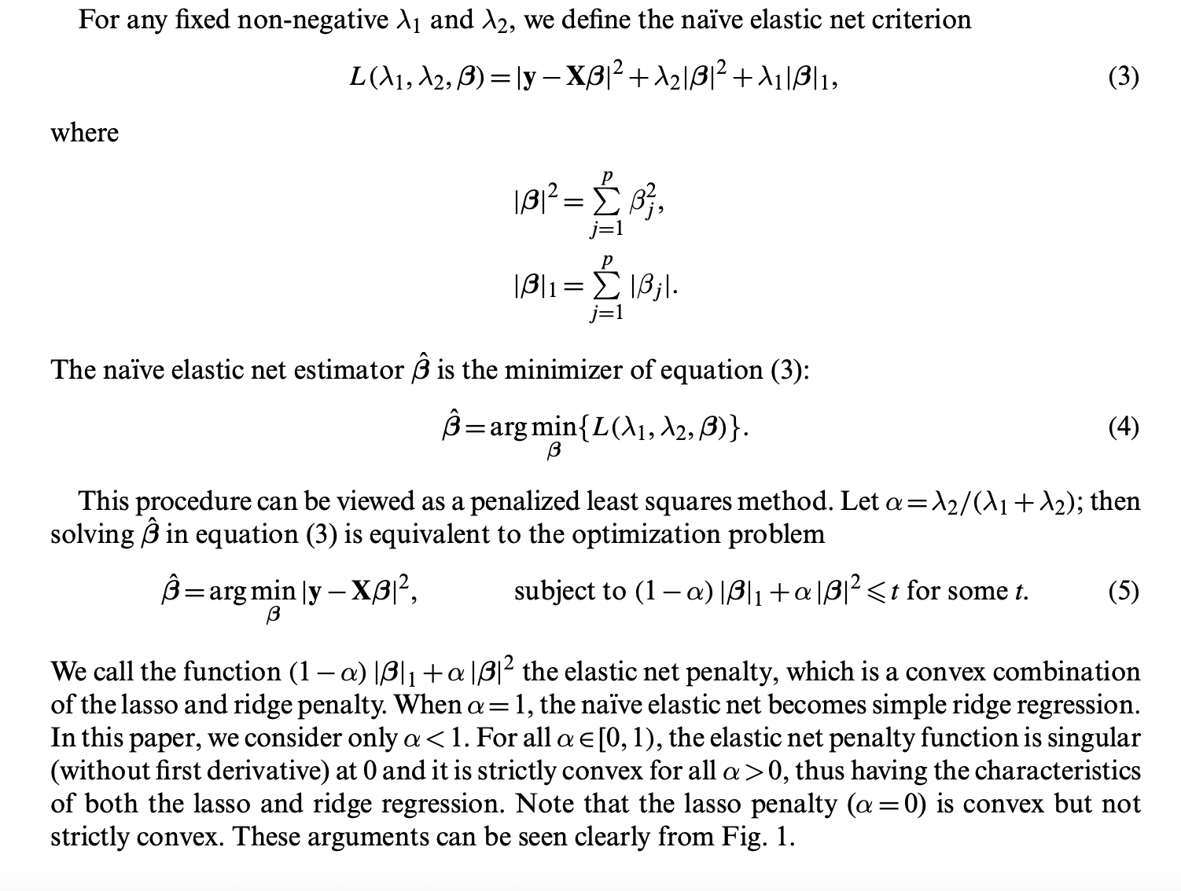

5:

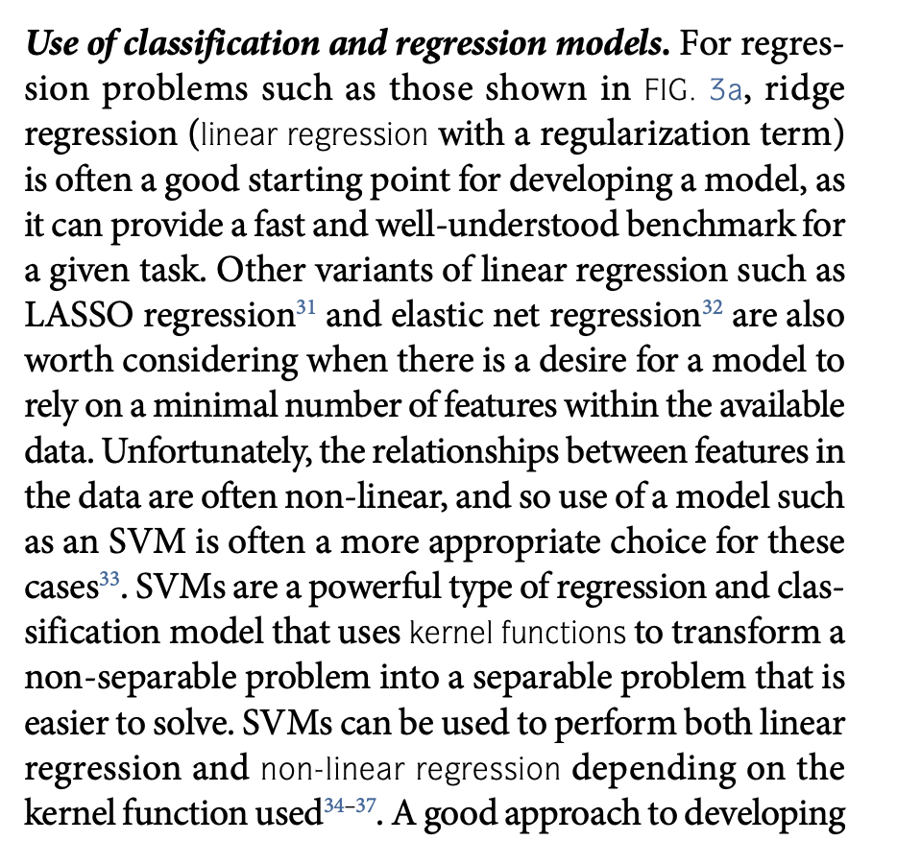

#### Support Vector Machines

Support vector regression defines a function that takes in datapoints and returns predictions that are within distance epsilon from the ground truth [9]. Support vectors are defined as the datapoints falling outside a cylinder of epsilon radius centred around the model’s predictions, and all model predictions are made using a linear combination of the support vectors [9]. Often, the input data is first transformed into a higher dimensionality feature space that enables more effective modelling of non-linear relationships [9].

#### Decision-Tree Based Methods

12

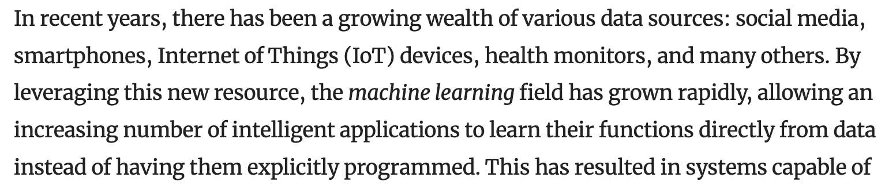

* One of the most popular learning models are Decision Trees (DTs). These models are usually represented in a flowchart-like structure, in which every internal node is a logical test (called a *split*), and every leaf is a prediction (see Fig. [1](https://link.springer.com/article/10.1007/s10462-022-10275-5#Fig1)a). During inference, each observation starts at the root and ends in one of the leaves, following a path that is completely transparent to the user. The simplicity of this approach belies its robustness: DTs are known not only as an interpretable model that is easy to grasp, but also as an accurate method that has stood the test of time, ever since their original proposal in the 1960s (Morgan and Sonquist [1963](https://link.springer.com/article/10.1007/s10462-022-10275-5#ref-CR97)). Trees present many other advantages as well, such as low computational cost, being able to deal with missing values, and out-of-the-box handling of mixed data (Hastie et al. [2009](https://link.springer.com/article/10.1007/s10462-022-10275-5#ref-CR50)).
* With the growing ubiquity of machine learning and automated decision systems, there has been a rising interest in explainable machine learning: building models that can be, in some sense, understood by humans
* By “traditional”, this survey refers to the greedy univariate trees built by CART (Classification and Regression Trees) (Breiman et al. 1984), which remains one of the most popular algorithms in the field, and also serves as the base for several other contributions
* Regarding terminology, this survey denotes that the goal of predictive models is to navigate a hypothesis set (e.g. the set of possible trees) and select a hypothesis (e.g. a particular tree) that is close to the target function that one wants to predict. To this end, a training dataset consisting of observations is used, with each observation being composed of attributes (that admit numerical, categorical, or binary values) and a target attribute (a label, in classification tasks, or a constant number, in regression tasks). An ideal hypothesis not only fits the training data (i.e. approximates), but also has similar performance in out-of-sample data taken from the same distribution (i.e. generalizes)
* Structurally, traditional DTs are composed of two elements: internal nodes and leaves. Each internal node contains a logical test, called a split, of the form “attribute ≤ value” (for numerical attributes) or “attribute = value” (for categorical attributes). Since every split has a binary outcome of true or false, every node has two outgoing branches and the tree itself is also binary. The leaves, on the other hand, contain either a label or a constant number, and they serve as the tree’s possible outcomes, selected during the inference step through successive application of the splits
* The process of building DTs from training data is usually called decision tree induction, and to understand how it is traditionally done, it is useful to visualize a DT as a specific partitioning of the input space. This interpretation is more readily apparent with numerical attributes, and it is illustrated in Fig. 1b alongside the usual flowchart depiction. The root node splits the space into two disjoint partitions, which are passed along to its left and right child nodes. Each of these nodes further splits the partitions they received by applying their own tests and then passing them along to their children. This process is repeated until a leaf is reached, as the leaves correspond to the partitions themselves and contain the predictions associated with each region of the input space. In this context, the induction process can be seen as an optimization problem, in which the goal is to partition the input space in a way that correctly predicts the target function, while using as few partitions as possible
* Traditional algorithms solve this problem through a greedy approach that iteratively selects the most informative splits.
* In other words, the first split is more informative because it divides the dataset into pure partitions (i.e. every element has the same label)
  + This impurity is captured by a measure called splitting criterion, which for classification tasks is usually either entropy-based information gain (Quinlan 1986) or Gini impurity (Breiman et al. 1984)
* From this measure, an induction algorithm follows naturally: the tree can be built one node at a time, in a greedy way that always selects the best split according to the splitting criterion. Because each node considers only the data that has been passed to it from its parent, the procedure fits well with a recursion, and it is aptly called recursive partitioning
* Since this procedure will not stop until all the leaves contain pure partitions, it is guaranteed to induce a tree that perfectly classifies the training data. This is great news for the fitting capacity of the model, as the tree will adapt to the complexity of the target function and grow as large as it is necessary to represent it. However, it is also terrible news concerning generalization: in the worst case, pure partitions can only be provided by an exponentially-large tree that has one leaf for every observation in the dataset, which is analogous to fitting N points using a polynomial function of the (N − 1)th degree. For this reason, the procedure presented above usually results in overfitting, which is one of the reasons why DTs have been accused of having low bias and high variance (Breiman et al. 1984, Sect. 3.1). Fortunately, this weakness of DT algorithms (sometimes called overpartitioning) has been extensively studied, and indeed one of the reasons for CART’s popularity is precisely the way by which it alleviates this problem: instead of stopping the procedure before the tree overfits (called pre-pruning), the algorithm lets the overfitting occur and then eliminates some of the branches from the tree (called post-pruning)
* A fundamental topic in machine learning is approximation: the ability of a model to select a hypothesis that can fit a training dataset by minimizing the associated error. A model with low approximation capacity is unable to approximate complex target functions, regardless of the size of the training dataset (e.g., a linear model is unable to adequately approximate a sinusoidal target function). On the other hand, a model with an excessive high approximation capacity, for a given training set size, can end up overfitting the training data.
  + There are many aspects of DTs that impact their ability to approximate. The most immediate one is size: a tree with a single split (also called a stump) can only represent a single line that is orthogonal to its associated attribute; on the other hand, a tree with many nodes is capable of representing this single line and much more. Although growing larger trees has a positive effect concerning approximation, several other aspects may impact this ability. The following sections consider multivariate splits, model leaves, trees for datasets with particular data characteristics, and non-greedy trees.
* Traditionally, the splits in a DT are univariate: they evaluate a single attribute at a time, generally in the form of xi ≤ c for numerical attributes and xi = c for categorical ones. As a result, these univariate splits correspond to hyperplanes that are orthogonal to the tested attributes and parallel to all others, which renders them the alternative name axis-parallel splits. Splits of this kind are employed because they are simple to interpret and optimize, but they have their drawbacks: a DT with univariate splits (called a univariate tree) is a composition of orthogonal lines, and as such, it is restricted to representing hyper-rectangles in the attribute space, an effect illustrated in Fig. 5a. When facing target functions such as a simple linear combination between two attributes, univariate DT algorithms may end up inducing unnecessarily large trees that may be not only hard to interpret, but also unable to adequately approximate the target function. The most popular solution to this problem is the induction of trees that consider multiple attributes in each split, called multivariate trees. Since the splits are no longer limited to orthogonal lines, the tree can represent much more than hyper-rectangles, therefore enhancing its approximation capacity. However, this improvement also brings its own set of disadvantages: multivariate splits are considered to be less interpretable than their univariate counterparts (Breiman et al. 1984, Sect. 5.2.2), and they are significantly more timeconsuming to induce (since there are many more attributes to consider). Consequently, the use of multivariate trees should be evaluated depending on the complexity of the task and the size of the available sample
* While multivariate trees employ more complex splits, other trees employ more complex leaves. Model trees are DTs with predictive models in their leaves, instead of labels or constant numbers.
* However, there has been some debate over the effectiveness of greedy approaches. In particular, it can be argued that such algorithms are only one-step optimal and not overall optimal, since the construction procedure only considers the quality of the next split and not of future splits on the same path
  + Lookahead search is an intuitive approach to reduce the shortsightedness of greedy algorithms: instead of selecting the optimal split with regards to the next iteration, a k-lookahead selects the optimal split relating to the next k iterations
  + A different approach for avoiding sub-optimality is inducing trees through evolutionary algorithms (EAs; Mitchell 1998). Instead of building a single tree, these methods build several trees and randomly modify and combine them using “genetic operators” until a satisfactory solution is found. Moreover, instead of using a splitting criterion to compare candidate splits at each internal node, these methods compare multiple DTs at each iteration using a “fitness function” (usually a weighted sum of tree size and accuracy). Overall, it has been argued that by evaluating the performance of entire trees at once, EAs avoid the sub-optimality trap, and therefore produce more accurate trees (Barros et al. 2012). The more complex search comes with two main downsides: a higher computational cost, and a large number of hyperparameters that need to be somehow adequately determined
* Gradient-based optimization has been increasingly explored as an alternative to greedy DT induction. Although this idea is not new (Jordan and Jacobs 1994; Suarez and Lutsko 1999), the last decade’s renaissance in deep learning has prompted many members of the artificial neural networks (ANNs) community to experiment with using backpropagation-inspired approaches in other methods, such as DTs. Most of these contributions are motivated by the sub-optimality argument—greedy algorithms produce sub-optimal trees, therefore the non-greedy gradient-based optimization may help (Suarez and Lutsko 1999; Irsoy et al. 2012, 2014; Norouzi et al. 2015), but with the recent interest in explainable AI, an increasing number of works also report being inspired by the potential of a hybrid model that combines DT’s interpretability with ANN’s accuracy
  + Regardless of the motivation, all such approaches face a common challenge: gradient-based optimization requires continuous and differentiable functions, but traditional DTs are defined by discrete and non-linear decisions, such as selecting which attribute will be used in a split or if an observation goes left or right. To resolve this contradiction, gradient-based methods replace the traditional hard DT architecture with a softer version that is more amenable for differentiation. This is done via two major modifications: the nature of the splits, and how they are interpreted.
* The previous sections focused on different ways of enhancing the approximation capacity of DTs, but generalization is also a key concern. There is an intuitive trade-off between approximation and generalization: if a model has high representational power, it has a higher chance of perfectly representing the training data (overfitting) possibly at the expense of a poor generalization performance on the out-of-sample data. Conversely, if a model has low representational power, overfitting is less probable and the out-of-sample results will be probably comparable to the in-sample accuracy, although one should be aware that the models may end up underfitted. This situation is analogous to the bias–variance trade-off, and it is also related to the number of degrees of freedom involved in the models.
  + In the context of DTs, there is a strong connection between generalization and tree size: shallower trees have a lower representational capacity and tend to generalize better, whereas deeper trees correspondingly tend to generalize worse. Because of this, any technique that directly or indirectly reduces tree size can be seen as partly beneficial to generalization, which includes the previously seen multivariate splits (by enhancing the representational capacity of the nodes, the final tree may end up smaller) and non-greedy trees (a more optimal tree may have a lower number of nodes). But generalization concerns more than tree size: many of the topics presented as advantageous to approximation (Sect. 3) can also be understood as contributing negatively to generalization, since they enhance the representational capacity of the tree as a whole.
  + Possibly the most intuitive approach to tree size reduction is simply to stop growing the tree when it becomes too large (according to a pre-determined criterion). This approach is called pre-pruning, and it can be seen as an instance of the traditional early stopping procedure. In its most basic form, pre-pruning algorithms amount to applying a minimum threshold on the splitting criterion
  + The most popular tree simplification approach is post-pruning, sometimes simply called pruning. The main idea is to allow the DT to grow unimpeded, and then eliminate the subtrees that are introducing needless complexity to the model; this complexity is often measured on a validation set. Although slower than other methods such as pre-pruning, post-pruning has consistently been shown to improve accuracy, especially in tasks with a high level of noise
* DTs are closely related to interpretability: not only are they often regarded as a particularly interpretable model (Freitas 2014), but also interpretability itself is regarded as the “biggest single advantage of the tree-structured approach” (Breiman and Friedman 1988). However, not all DTs are equally interpretable, or even interpretable at all, e.g. a tree with thousands of nodes is much more difficult to grasp than a shallower version of it
  + Tree size is the aspect most commonly associated with interpretability: shallow trees are regarded as very interpretable, whereas deep trees are not
  + But although tree size is important to interpretability, it does not capture this notion entirely. As argued by Freitas (2014), users may find a larger tree to be more interpretable than a shallower version of it, if the splits of the larger model better reflect the user’s domain knowledge. This exemplifies the fact that size is only a syntactic notion, and that the semantic aspects of the model (its contents) must be considered for a fuller picture of interpretability.
  + Therefore, depending on the task, a large tree may not be as uninterpretable if the most common use cases are closer to the root

#### Ensemble Based Methods

13:

* Combining the predictions from several models has proven to be an elegant approach for increasing the performance of the models. Combination of several different predictions from different models to make the final prediction is known as ensemble learning or ensemble model. The ensemble learning involves multiple models combined in some fashion like averaging, voting such that the ensemble model is better than any of the individual models. To prove that average voting in an ensemble is better than individual model, Marquis de Condorcet proposed a theorem wherein he proved that if the probability of each voter being correct is above 0.5 and the voters are independent, then addition of more voters increases the probability of majority vote being correct until it approaches 1
  + s. Assumptions of Marquis de Condorcet theorem also holds true for ensembles (Hansen and Salamon, 1990). The reasons for the success of ensemble learning include: statistical, computational and representation learning (Dietterich, 2000), bias–variance decomposition (Ko
* Bagging reduces the variance among the base classifiers (Breiman, 1996b) while as boosting based ensembles lead to the bias and variance reduction (Breiman, 1996a; Zhang and Zhang, 2008)
* The second reason is computational wherein a learning algorithm stucks in a local optima due to some form of local search. Ensemble model overcomes this issue by performing some form of local search via different starting points which leads to better approximation of the true unknown function. Another reason is representational wherein none of the hypotheses among the set of hypothesis is able to represent the true unknown function. Hence, ensembling of these hypothesis via some weighting technique result
  + One of the main reasons behind the success of ensemble methods is increasing the diversity among the base classifiers and the same thing was highlighted in Dietterich (2000)
* The main idea in bagging is to generate a series of independent observations with the same size, and distribution as that of the original data. Given the series of observations, generate an ensemble predictor which is better than the single predictor generated on the original data. Bagging increases two steps in the original models: First, generating the bagging samples and passing each bag of samples to the base models and second, strategy for combining the predictions of the multiple predict
  + the averaging strategy is used in regression problems for generating the ensemble output
  + Random Forest (Breiman, 2001) is an improved version of the decision trees that uses the bagging strategy for improving the predictions of the base classifier which is a decision tree. The fundamental difference between these two methods is that at each tree split in Random Forest, only a subset of features is randomly selected and considered for splitting. The purpose of this method is to decorrelate the trees and prevent over-fitting. Breiman (2001) showed heuristically that the variance of the bagged predictor is smaller than the original predictor and proposed that bagging is better in higher dimensional data
* Boosting technique is used in ensemble models for converting a weak learning model into a learning model with better generalization
  + a linear combination of weak learners in the regression problems results in better prediction as compared to the single weak learner. Boosting methods like AdaBoost (Freund and Schapire, 1996) and Gradient
* Ensembling can be done either by combining outputs of multiple base models in some fashion or using some method to choose the ‘‘best" base model. Fig. 4 shows the stacking technique. Stacking is one of the integration techniques wherein the meta-learning model is used to integrate the output of base models.
* emble is the most followed approach for fusing the decisions in the literature. Here, the outcomes of the base learners are averaged to get the final prediction of the ensemble model.
  + Unweighted averaging is a reasonable choice when the performance of the base learners is comparable,
* Similar to unweighted averaging, majority voting combines the outputs of the base learners. However, instead of taking the average of the probability outcomes, majority voting counts the votes of the base learners and predicts the final labels as the label with the majority of votes. In comparison to unweighted averaging, majority voting is less biased towards the outcome of a particular base learner as the effect is mitigated by majority vote count. However, favoring of a particular event by most of the similar base learners or dependent base learners leads to the dominance of the event in the ensemble model
* ier, Van der Laan et al. (2007) proposed super learner which is weighted combination of the predictions of the base learner. Unlike the stacking approach, it uses cross validation approach to select the optimal weights for combining the predictions of the base learners.

14:

* Ensemble learning is a machine learning approach that attempts to improve predictive performance by mixing predictions from many models. Employing ensemble models aims to reduce prediction generalisation error [1]. The ensemble technique decreases model prediction error when the base models are diverse and independent. The technique turns to the collective output of individuals to develop a forecast. Despite numerous base models, the ensemble model operates and performs as a single model [2]. Most real data mining solutions employ ensemble modelling methodologies. Ensemble approaches combine different machine learning algorithms to create more accurate predictions than those made by a single classifier [3]. The ensemble model’s main purpose is to combine numerous weak learners to form a powerful learner, boosting the model’s accuracy [4]. The main sources of the mismatch between real and predicted values when estimating the target variable using any machine-learning approach are noise, variation, and bias
* Bagging, boosting, stacking, and voting are the four major classes of ensemble learning algorithm
* Bagging is aggregating the predictions of many decision trees that have been fit to different samples of the same dataset. Ensemble bagging is created by assembling a series of classifiers that repeatedly run a given algorithm on distinct versions of the training dataset [10]. Bagging, also known as bootstrapping [7], is the process of resampling data from the training set with the same cardinality as the starting set to reduce the classifier’s variance and overfitting [11]. Compared to a single model, the final model should be less overfitted. A model with a high variance indicates that the outcome is sensitive to the practice data provided [12]. As a result, even with more training data, the model may still perform poorly and may not even lower the variance of our model.
* We found that stacking has been used in half the studies considered for comparison with bagging and boosting, but it has shown 82.6% best performance accuracy. On the other hand, bagging has been used in most of the studies but showed the least prominent results of just 26.8%, followed by boosting, which has shown the best results 40.5% of the time
* Boosting algorithms use weighted averages to transform poor learners into strong ones. During boosting, the original dataset is partitioned into several subgroups. The subset is used to train the classifier, which results in a sequence of models with modest performance [7]. The elements that were incorrectly categorised by the prior model are used to build new subsets. The ensembling procedure then improves its performance by integrating the weak models using a cost function. It explained that, unlike bagging, each model functions independently before aggregating the inputs, with no model selection at the end. Boosting is a method of consecutively placing multiple weak pupils in a flexible manner. Intuitively, the new model focuses on the discoveries that have been shown to be the most difficult to match up until now, resulting in a good learner with less bias at the end of the process [10]. Boosting can be used to solve regression and identification problems, such as bagging
* The boosting approach trains a weak learner, computes its predictions, selects training samples that were mistakenly categorised, and then trains a subsequent weak learner with an updated training set that includes the incorrectly classified instances from the previous training session [15]. Boosting algorithms such as AdaBoost and Gradient Boosting have been applied in various sectors

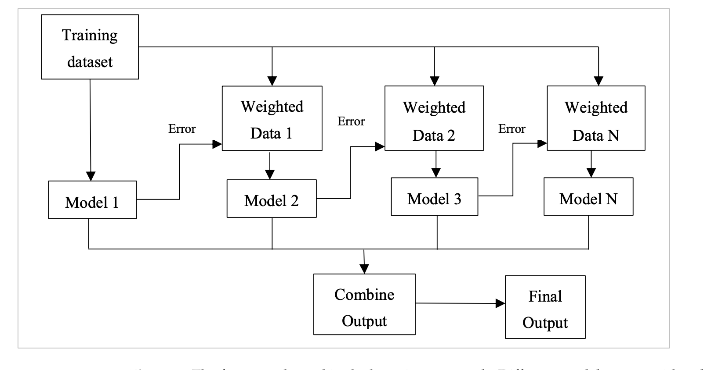

* cked with a metalearner classifier. The original data is used as input to numerous distinct models in stacking [5]. The metaclassifier is then utilised to estimate the input as well as the output of each model, as well as the weights [7]. The best-performing models are chosen, while the rest are rejected. Stacking employs a metaclassifier to merge multiple base classifiers trained using different learning methods on a single dataset. The model predictions are mixed with the inputs from each successive layer to generate a new set of predictions [17]. Ensemble stacking is also known as mixing because all data is mixed
  + The dataset is randomly divided into n equal sections in this procedure. One set is utilised for testing and the rest for training in the nth-fold cross-validation [8]. We derive the predictions of various learning models using these training testing pair subsets, which are then used as metadata to build the metamodel [18]. The metamodel produces the final forecast, commonly known as the winner-takes-all technique [5]. Stacking is an integrated approach that uses the metalearning model to integrate the output of base models. If the final decision element is a linear model, the stacking is also known as “model blending” or just “blending” [8]. Stacking involves fitting multiple different types of models to the same data and then using a different model to determine how to combine the results most efficiently
* The Voting Classifier ensemble approach is a strategy that aggregates predictions from numerous independent models (base estimators) to make a final prediction [19]. It uses the “wisdom of the crowd” notion to create more accurate predictions by taking into account the aggregate judgement of numerous models rather than depending on a single model. In the Voting Classifier, there are two types of voting: hard voting, in which each model makes a prediction, and soft voting, in which each model forecasts the probability or confidence ratings for each class or label. The final prediction is made by summing the expected probabilities across all models and choosing the class with the highest average probability [20]. Weighted voting allows multiple models to have different influences on the final forecast, which can be assigned manually or learned automatically based on the performance of the individual models. Because of this diversity, different models can affect the final prediction differently

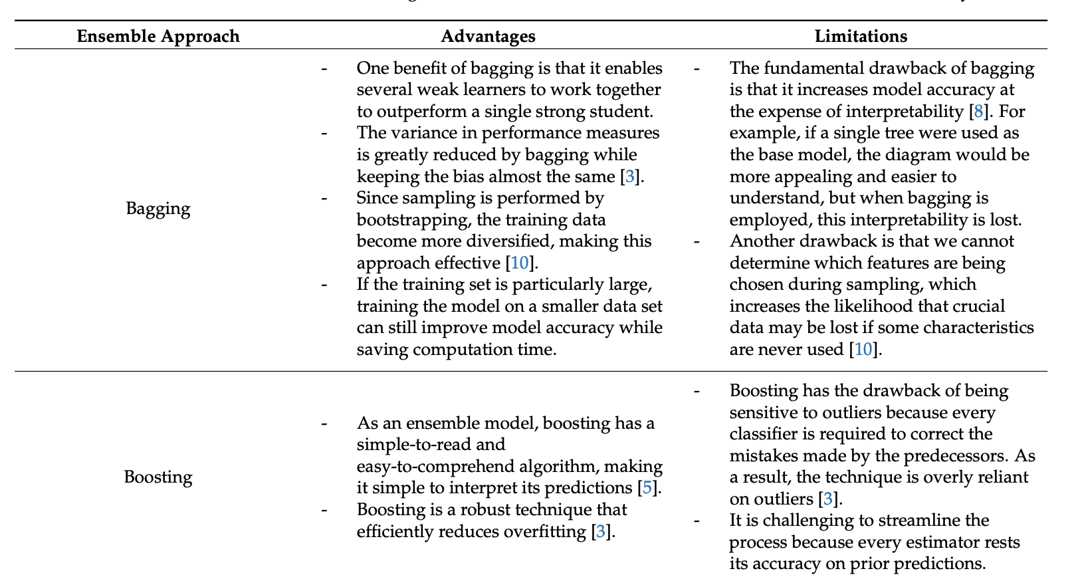

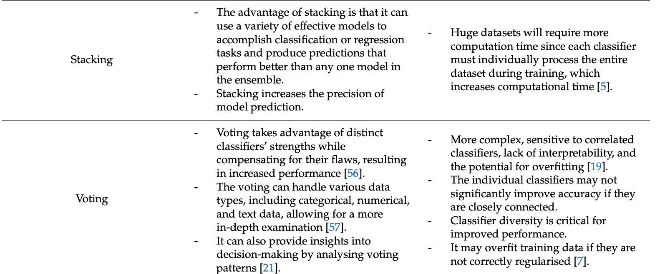

* Table 7 compares usage frequency and best performance for bagging, boosting, stacking and voting algorithms used in the reviewed articles, as outlined in Tables 1–5. Although boosting has been frequently employed (37 of 45), the frequency of the most accurate in percentage is only 40.5%. Stacking, on the other hand, was used in 23 of the 45 studies, but the accuracy rate is 82.6%. Random forest and random subspace are the upgraded 15 of 21 version of bagging, so in this comparison analysis, these approaches have been included in the bagging section. Bagging has produced the poorest outcomes, with the highest accuracy of only 26.8% with a usage frequency of 41 out of 45. Voting has also shown a good frequency of the best performance accuracy of 71.4%, but it appeared in seven out of 45 reviewed articles
* Stacking is a popular and efficient strategy for heart disease, skin cancer, liver disease, and diabetes prediction. It can capture and combine varied predictions from base models, uncovering hidden patterns and complicated connections between risk factors and symptoms [10]. It also captures nonlinear relationships, taking advantage of the flexibility of various modelling techniques to capture nonlinear patterns more successfully than other ensemble methods, such as bagging or boosting [34]. Stacking can combine predictions from several base models trained on distinct subsets or representations of the data, exploiting the strengths of each model while limiting the impact of data heterogeneity. It can address class imbalance issues in imbalanced datasets by optimising performance on minority classes and incorporating models with various uncertainty handling strategies, such as imputation approaches or robust estimation methods [4,8,37]. R

15:

* We call this procedure "bootstrap aggregating" and use the acronym bagging
* Bagging predictors is a method for generating multiple versions of a predictor and using these to get an aggregated predictor. The aggregation averages over the versions when predicting a numerical outcome and does a plurality vote when predicting a class. The multiple versions are formed by making bootstrap replicates of the learning set and using these as new learning sets. Tests on real and simulated data sets using classification and regression trees and subset selection in linear regression show that bagging can give substantial gains in accuracy. The vital element is the instability of the prediction method. If perturbing the learning set can cause significant changes in the predictor constructed, then bagging can improve accuracy

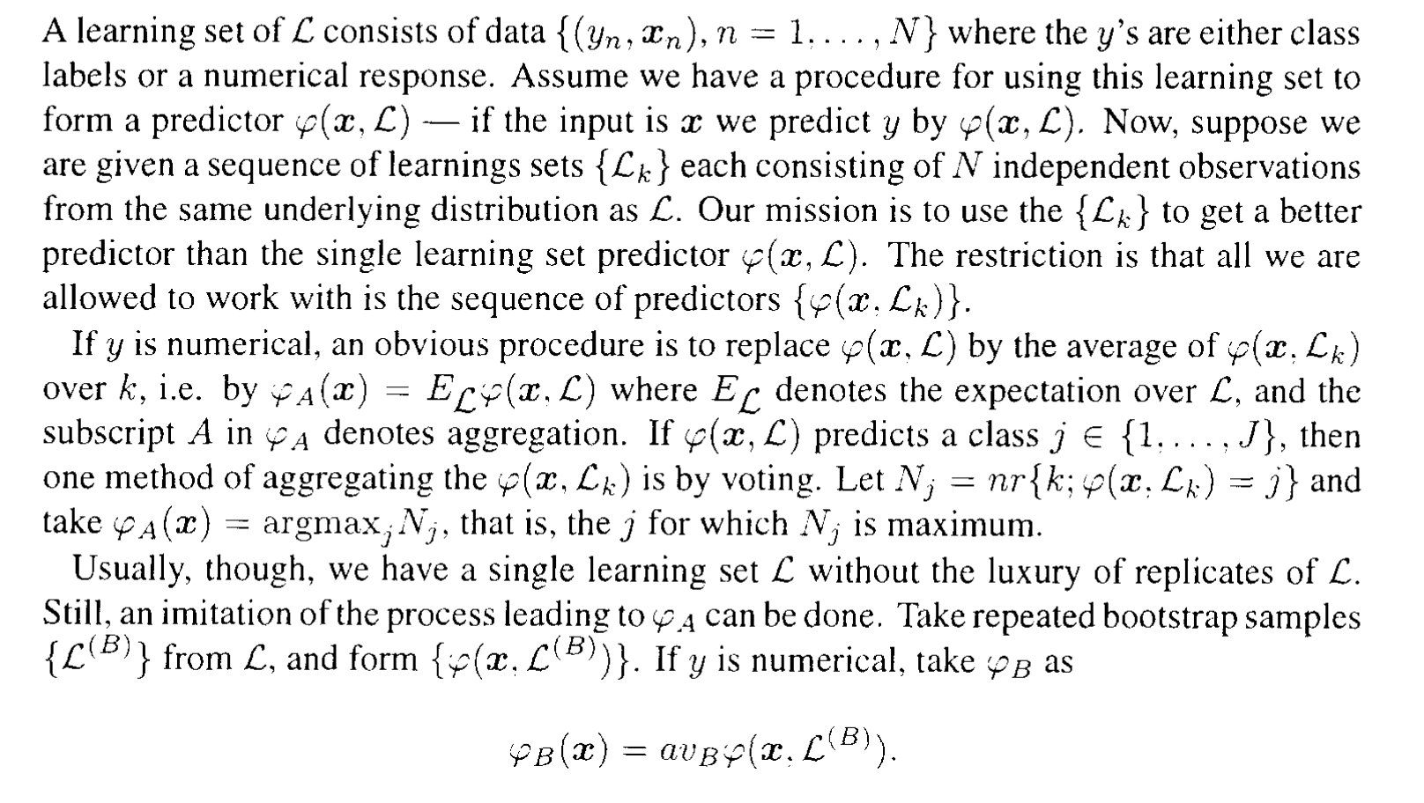

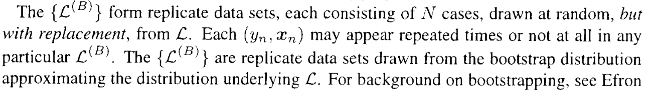

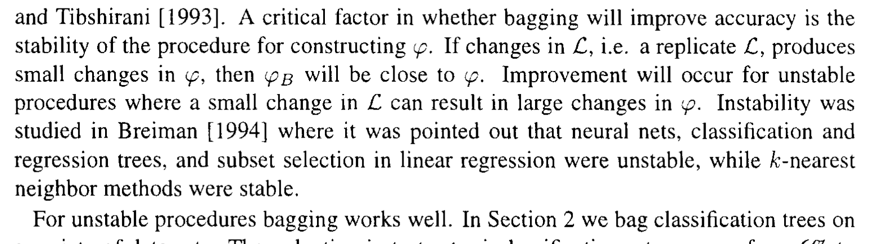

##### 19:

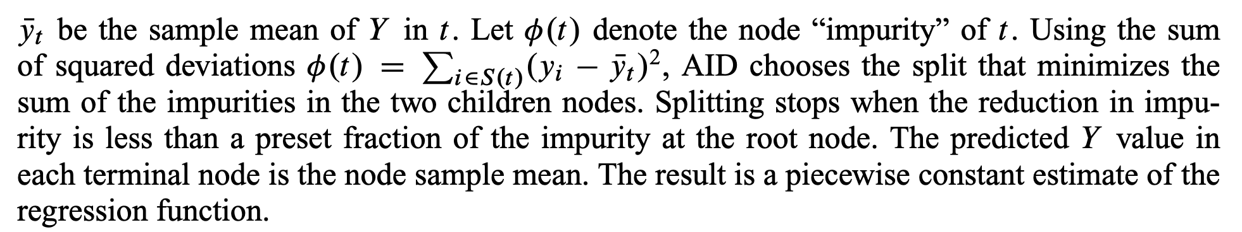

* At any node t, let S.t/ denote the set of training data in t an
* To dealwith missing data values at a node, CART uses a series of “surrogate” splits, which are splits onalternate variables that substitute for the preferred split when the latter is inapplicable becauseof missing values. Surrogate splits are also used to provide an importance score for each Xvariable. These scores, which measure how well the surrogate splits predict the preferred splits,can help to detect masking. CART can also employ linear splits, that is, splits on linear combi-nations of variables, by stochastic search.
* AID and CART construct piecewise constant regression trees by using the node mean of Yas predicted value and the sum of squared deviations as node impurity function.
* Missing values may be given a separate category or be dealt with throughsurrogates splits as in CART.

##### Random Forest

##### Boosting

16:

* Boosting is an ensemble machine learning technique that combines several weak learners to form a strong learner. Boosting is used for both classification and regression problems. In boosting, weak learners are built sequentially where each weak learner tries to correct the errors of the previous learner in order to improve the prediction of the model. The final prediction of the model aggregates the outputs of all the weak learners in the ensemble. Although any base model can be a weak learner, usually decision trees are used as the weak learners in boosting since they proved their efficiency and ability to handle prediction problems effectively. There are several types of boosting algorithms and frameworks such as AdaBoost (Adaptive Boosting), Gradient Boosting, XGBoost (Extreme Gradient Boosting), CatBoost (Categorical Boosting) and LightGBM (Light Gradient Boosting Machine)
  + AdaBoost is one of the earliest boosting algorithms. The algorithm starts by assigning equal weights to all data points. In the next iteration of the algorithm, misclassified points are given higher weights to direct the subsequent weak learner to focus on these misclassified points. The algorithm proceeds in this manner for a specified number of iterations. In AdaBoost the weak learners are usually stumps where a stump is a onelevel tree.
* Gradient boosting (GB) algorithm also creates multiple weak learners to form a strong learner. A weak learner is first built to predict the output variable. Then, in the subsequent iteration another weak learner is built, however, this time the weak learner is built to learn the residual errors of the previous weak learner. Then subsequent iterations proceed in this manner where every weak learner tries to predict the residual errors of the previous learner. Weak learners are built in a sequential manner. Each weak learner is trained to minimize the loss function of the previous model using gradient descent. Gradient boosting trees (GBT) use trees as the base learners of the model
  + Gradient boosting builds an ensemble of weak learners in which each weak learner tries to correct the errors of its predecessor. Gradient boosting algorithm follows an iterative process where in each iteration the gradient of the loss function is computed, and a new weak learner is trained to minimize this gradient. The algorithm runs for a specific number of iterations until a stopping criterion is met.
  + XGBoost is an open-source library including a specific implementation of gradient boosting. XGBoost uses regularization techniques to overcome overfitting. It also parallelizes the formation of learners to improve the computational time of the training process.
  + LightGBM is a gradient boosting framework that was developed by Microsoft, and it is based on trees. It is a fast and distributed framework. It splits the tree leaf-wise whereas other techniques split the tree level-wise which makes it memory-efficient.
* A weak learner is a simple model that performs slightly better than a random model. On the other hand, a strong learner is a model that could achieve small error rates given enough training data

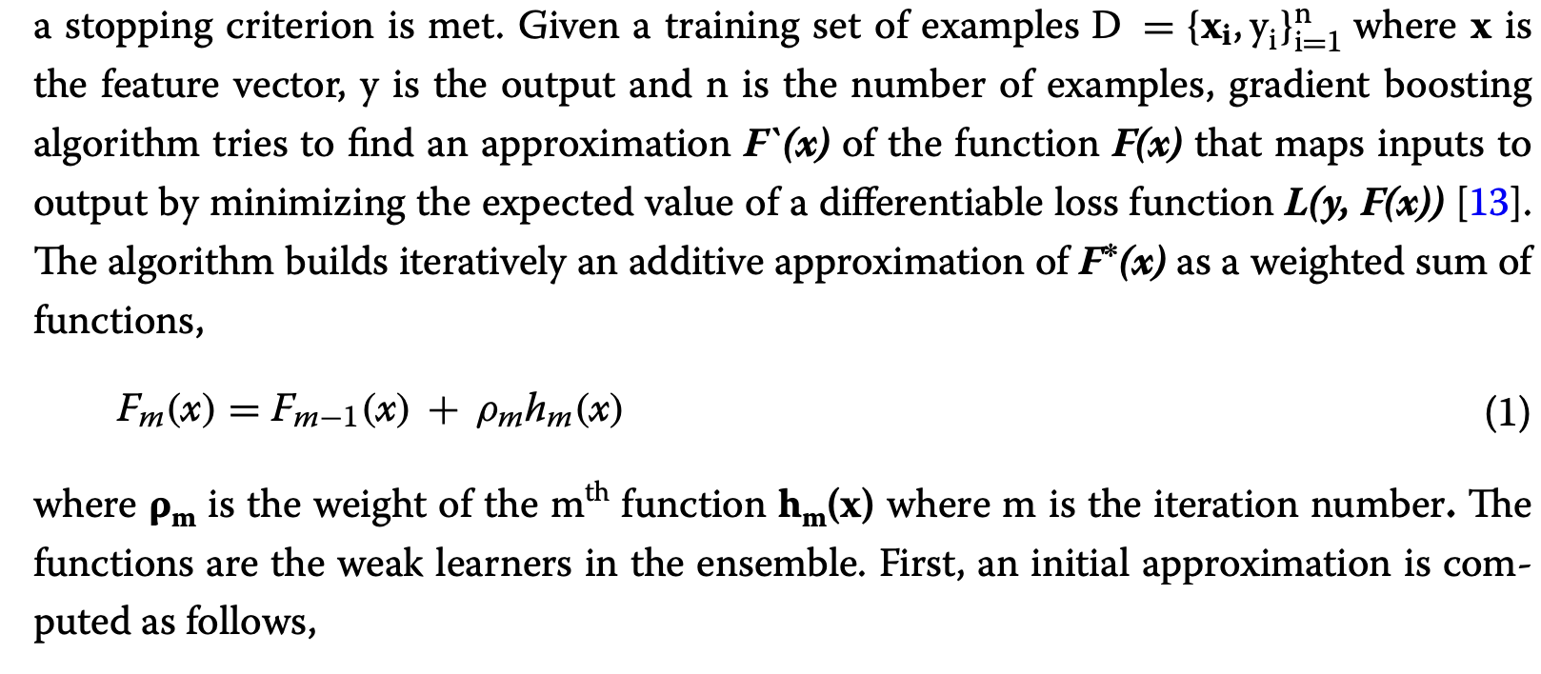

##### XGBoost

17:

* Tree boosting has been shown to give state-of-the-art results on many standard classification benchmark
* In this paper, we describe XGBoost, a scalable machine learning system for tree boosting. The system is available as an open source package2 . The impact of the system has been widely recognized in a number of machine learning and data mining challenges.

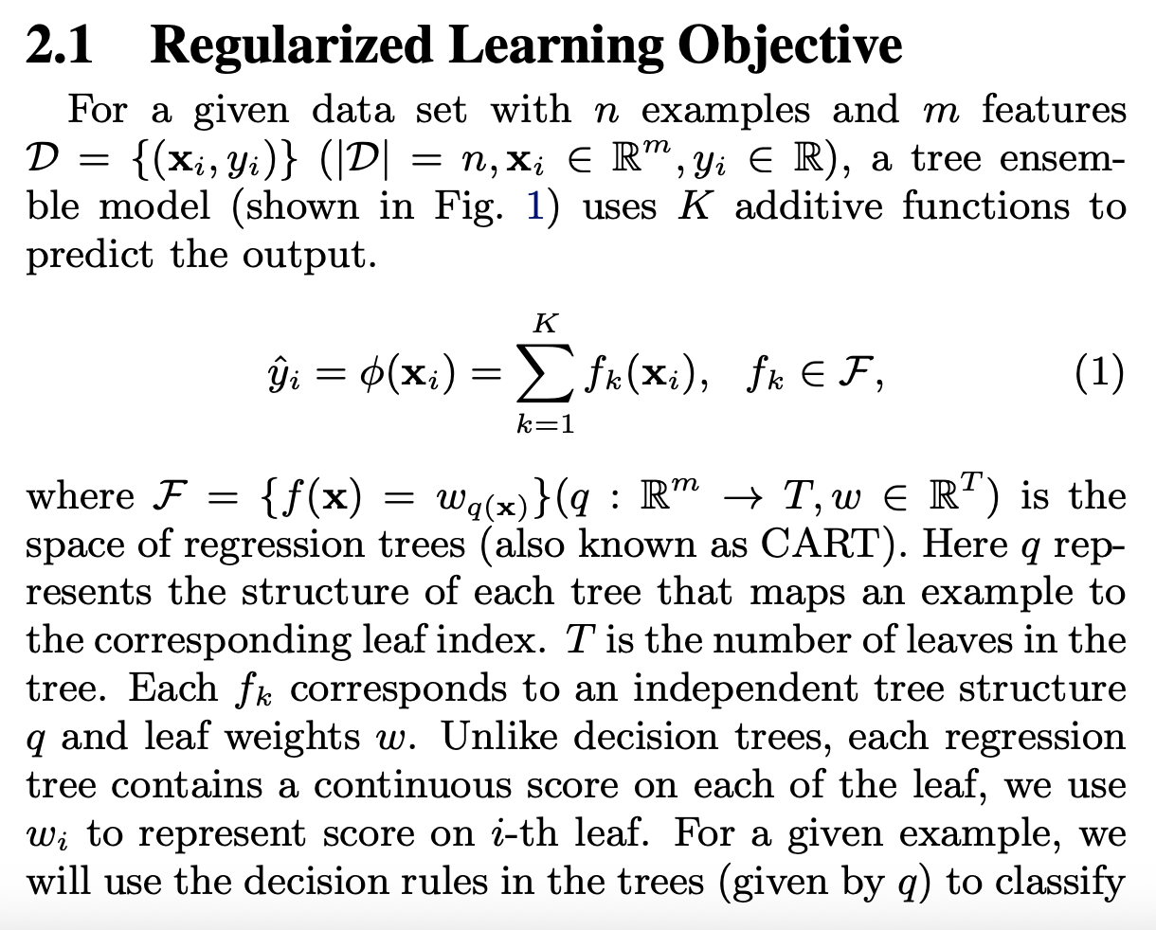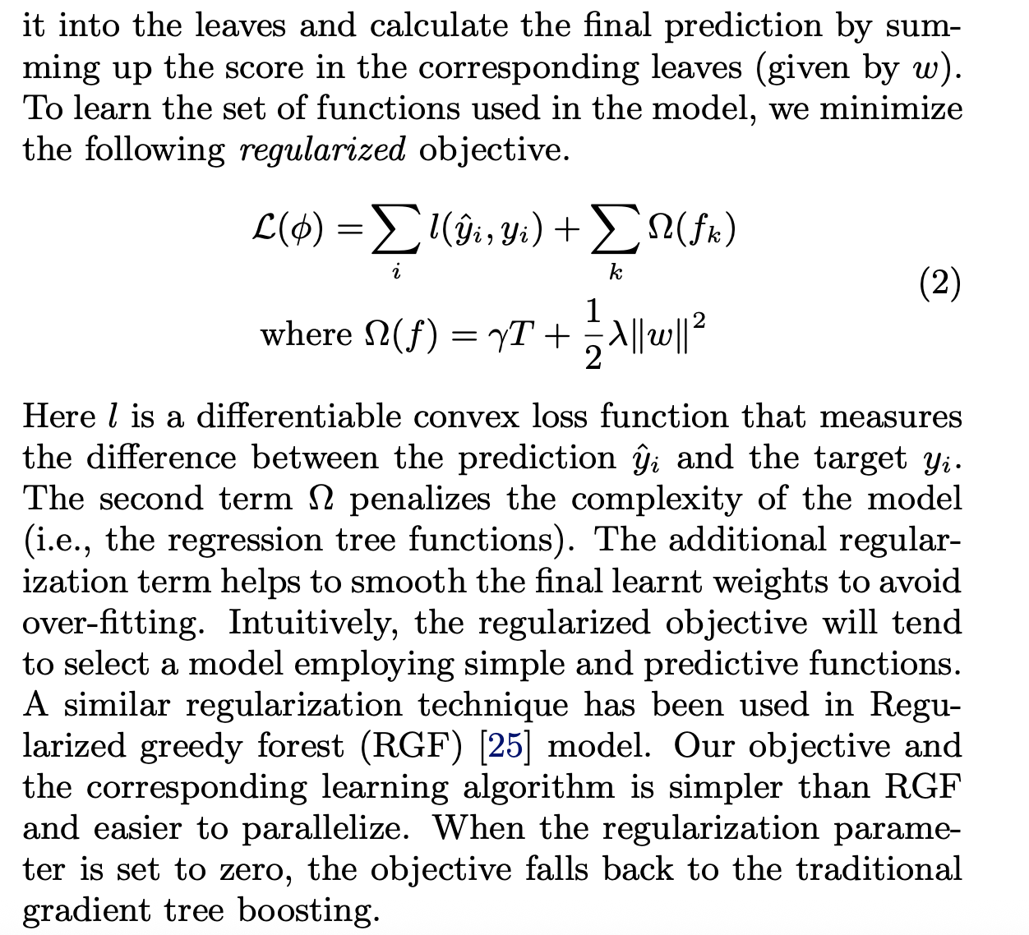

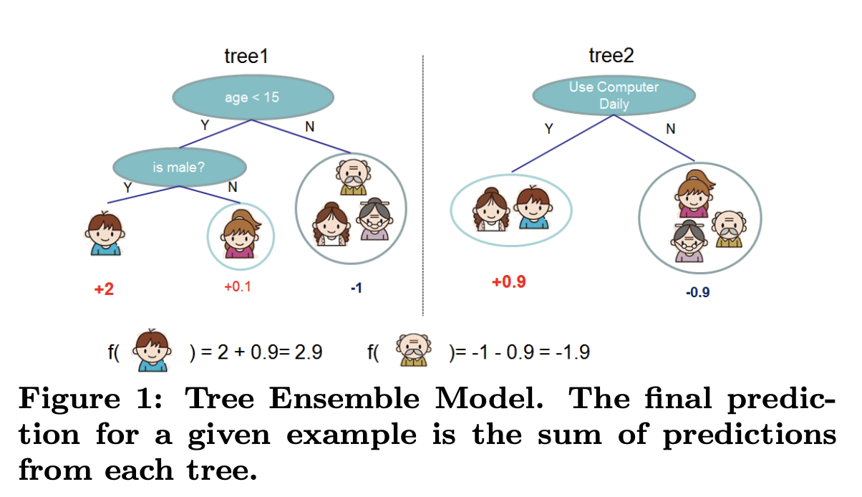’ 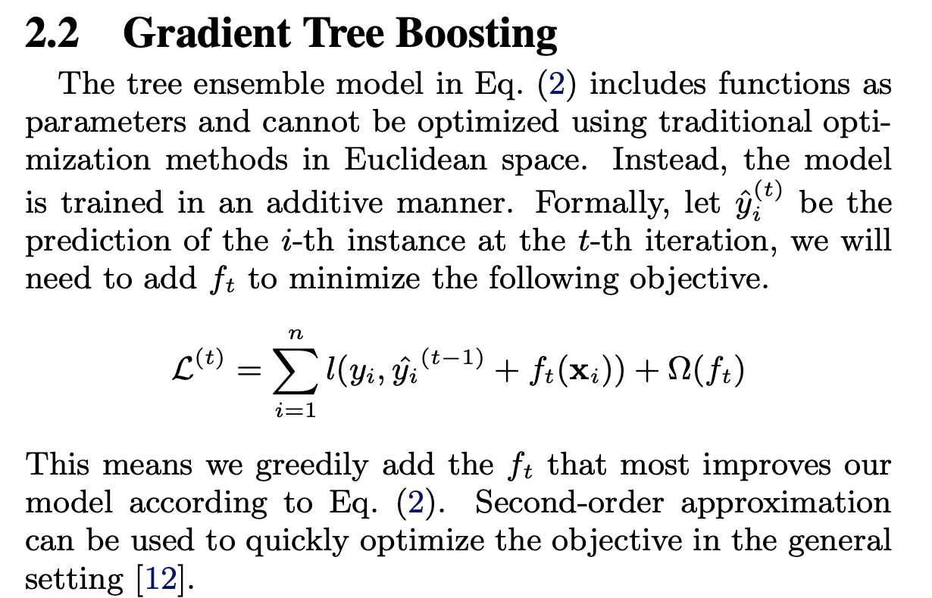 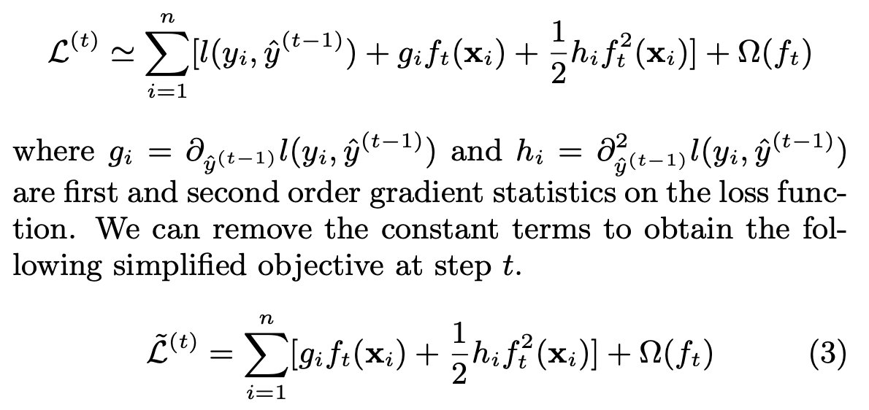

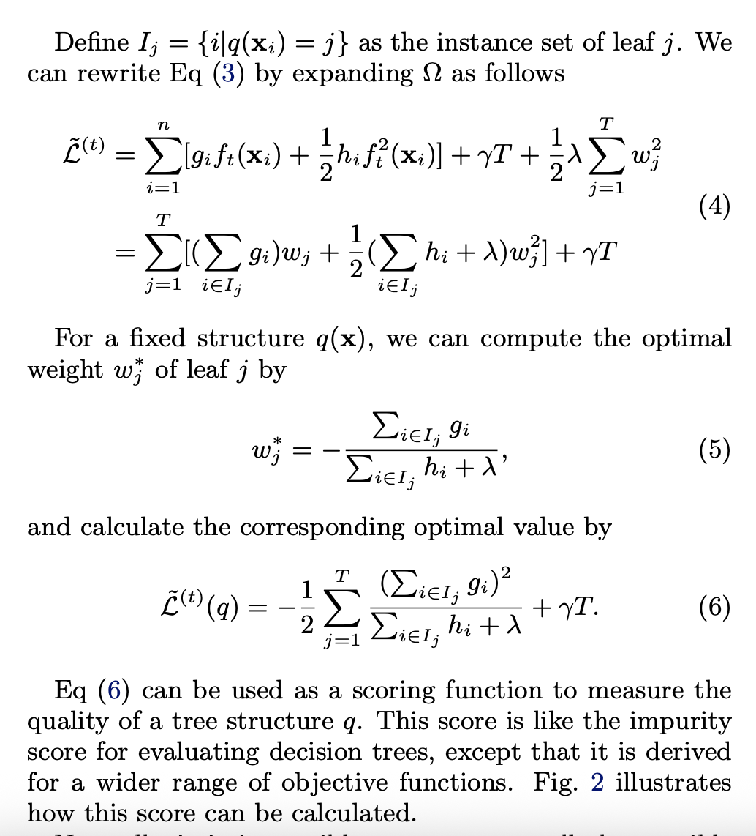 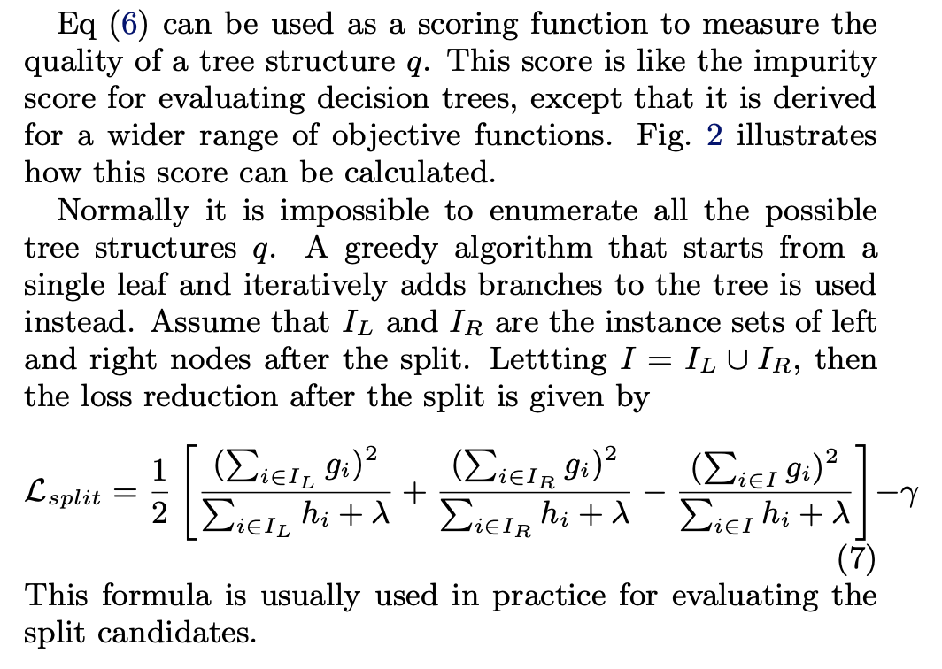

* Besides the regularized objective mentioned in Sec. 2.1, two additional techniques are used to further prevent overfitting. The first technique is shrinkage introduced by Friedman [11]. Shrinkage scales newly added weights by a factor η after each step of tree boosting. Similar to a learning rate in tochastic optimization, shrinkage reduces the influence of each individual tree and leaves space for future trees to improve the model. The second technique is column (feature) subsampling. This technique is used in RandomForest [4,13]. According to user feedback, using column sub-sampling prevents over-fitting even more so than the traditional row sub-sampling (which is also supported). The usage of column sub-samples also speeds up computations of the parallel algorithm described later.
* One of the key problems in tree learning is to find the best split as indicated by Eq (7). In order to do so, a split finding algorithm enumerates over all the possible splits on all the features. We call this the exact greedy algorithm. Most existing single machine tree boosting implementations, such as scikit-learn [20], R’s gbm [21] as well as the single machine version of XGBoost support the exact greedy algorithm. The exact greedy algorithm is shown in Alg. 1. It is computationally demanding to enumerate all the possible splits for continuous features. In order to do so efficiently, the algorithm must first sort the data according to feature values and visit the data in sorted order to accumulate the gradient statistics for the structure score in Eq (7).
* The exact greedy algorithm is very powerful since it enumerates over all possible splitting points greedily. However, it is impossible to efficiently do so when the data does not fit entirely into memory. Same problem also arises in the distributed setting. To support effective gradient tree boosting in these two settings, an approximate algorithm is needed.
* To summarize, the algorithm first proposes candidate splitting points according to percentiles of feature distribution (a specific criteria will be given in Sec. 3.3). The algorithm then maps the continuous features into buckets split by these candidate points, aggregates the statistics and finds the best solution among proposals based on the aggregated statistics.
  + Usually percentiles of a feature are used to make candidates distribute evenly on the data.

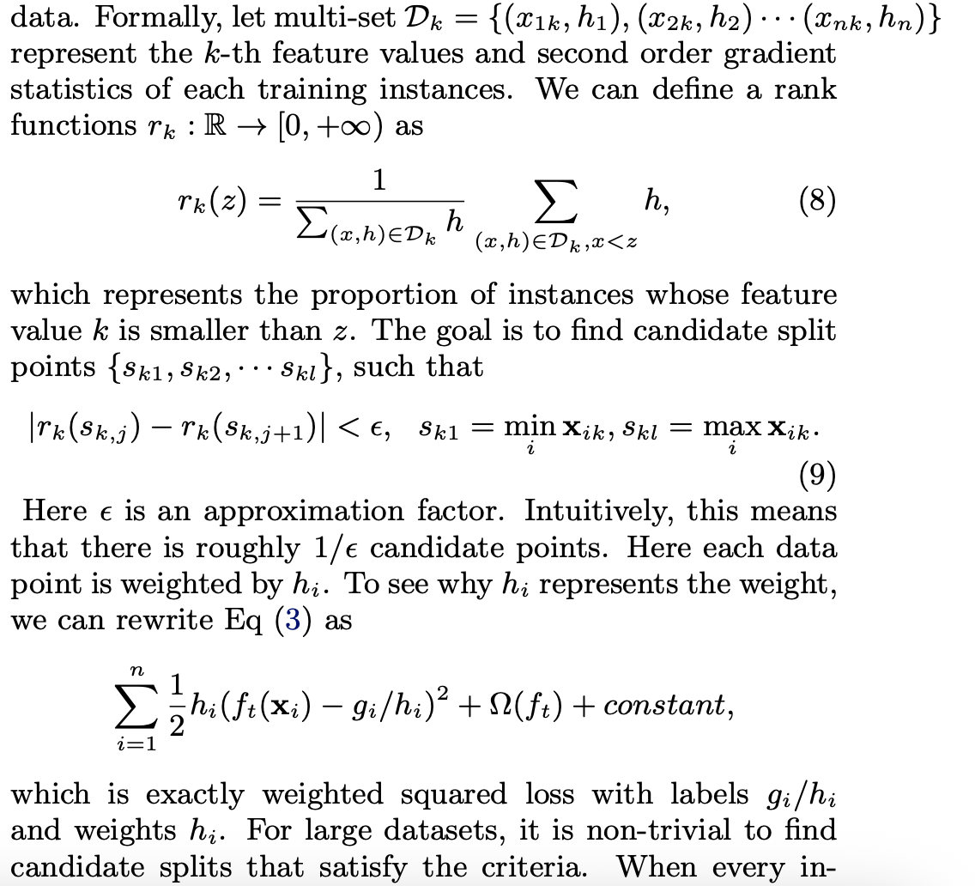

* In many real-world problems, it is quite common for the input x to be sparse. There are multiple possible causes for sparsity: 1) presence of missing values in the data; 2) frequent zero entries in the statistics; and, 3) artifacts of feature engineering such as one-hot encoding. It is important to make the algorithm aware of the sparsity pattern in the data. In order to do so, we propose to add a default direction in each tree node, which is shown in Fig. 4. When a value is missing in the sparse matrix x, the instance is classified into the default direction. There are two choices of default direction in each branch. The optimal default directions are learnt from the data.
* The key improvement is to only visit the non-missing entries Ik. The presented algorithm treats the non-presence as a missing value and learns the best direction to handle missing values. The same algorithm can also be applied when the non-presence corresponds to a user specified value by limiting the enumeration only to consistent solutions. To the best of our knowledge, most existing tree learning algorithms are either only optimized for dense data, or need specific procedures to handle limited cases such as categorical encoding. XGBoost handles all sparsity patterns in a unified way. More importantly, our method exploits the sparsity to make computation complexity linear to number of non-missing entries in the input

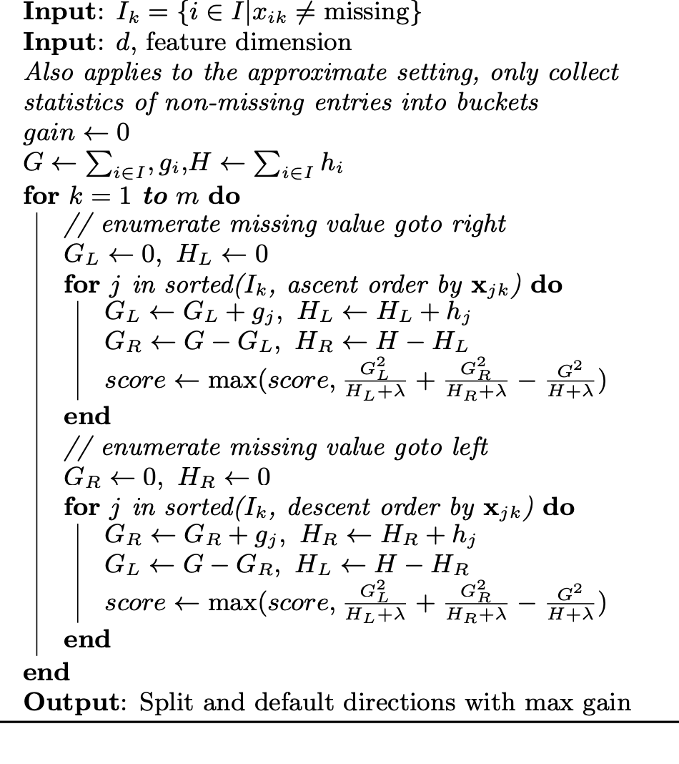

##### LightGBM

18:

* Gradient boosting decision tree (GBDT) [1] is a widely-used machine learning algorithm, due to its efficiency, accuracy, and interpretability. GBDT achieves state-of-the-art performances in many machine learning tasks, such as multi-class classification [2], click prediction [3], and learning to rank [4]. In recent years, with the emergence of big data (in terms of both the number of features and the number of instances), GBDT is facing new challenges, especially in the tradeoff between accuracy and efficiency. Conventional implementations of GBDT need to, for every feature, scan all the data instances to estimate the information gain of all the possible split points. Therefore, their computational complexities will be proportional to both the number of features and the number of instances. This makes these implementations very time consuming when handling big data.
  + GBDT is an ensemble model of decision trees, which are trained in sequence [1]. In each iteration, GBDT learns the decision trees by fitting the negative gradients (also known as residual errors).
* Gradient-based One-Side Sampling (GOSS). While there is no native weight for data instance in GBDT, we notice that data instances with different gradients play different roles in the computation of information gain. In particular, according to the definition of information gain, those instances with larger gradients1 (i.e., under-trained instances) will contribute more to the information gain. Therefore, when down sampling the data instances, in order to retain the accuracy of information gain estimation, we should better keep those instances with large gradients (e.g., larger than a pre-defined threshold, or among the top percentiles), and only randomly drop those instances with small gradients. We prove that such a treatment can lead to a more accurate gain estimation than uniformly random sampling, with the same target sampling rate, especially when the value of information gain has a large range
  + In this section, we propose a novel sampling method for GBDT that can achieve a good balance between reducing the number of data instances and keeping the accuracy for learned decision trees.
  + That is, if an instance is associated with a small gradient, the training error for this instance is small and it is already well-trained
  + GOSS keeps all the instances with large gradients and performs random sampling on the instances with small gradients. In order to compensate the influence to the data distribution, when computing the information gain, GOSS introduces a constant multiplier for the data instances with small gradients (see Alg. 2).

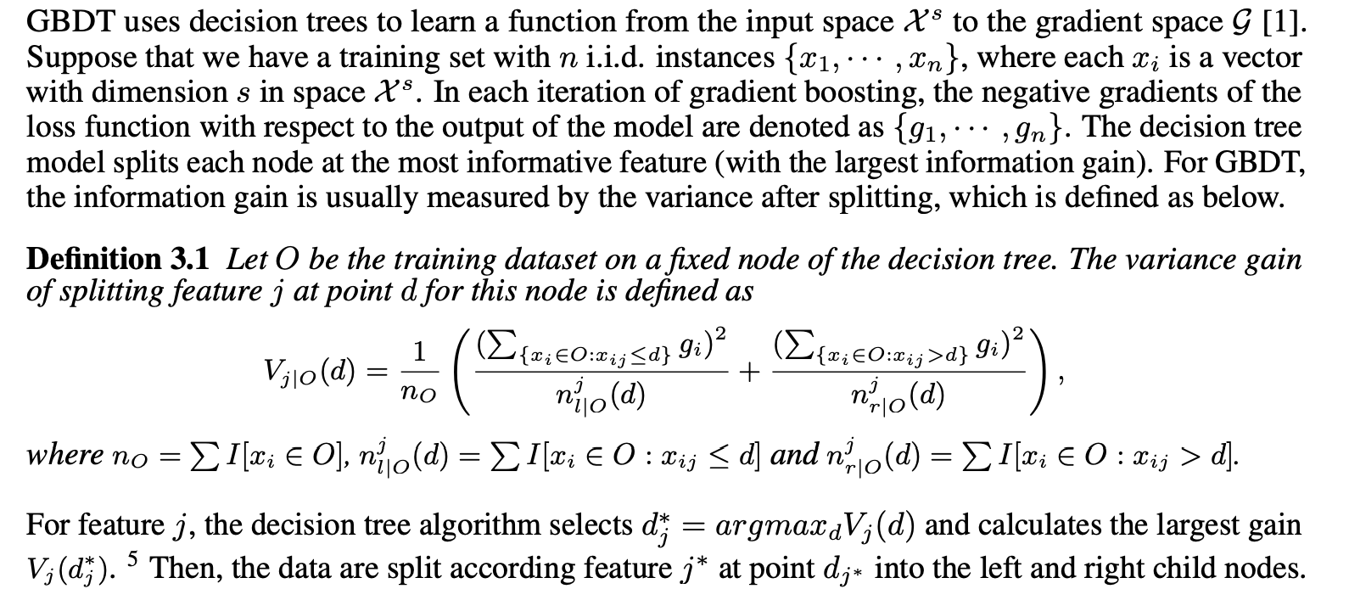

* Exclusive Feature Bundling (EFB). Usually in real applications, although there are a large number of features, the feature space is quite sparse, which provides us a possibility of designing a nearly lossless approach to reduce the number of effective features. Specifically, in a sparse feature space, many features are (almost) exclusive, i.e., they rarely take nonzero values simultaneously. Examples include the one-hot features (e.g., one-hot word representation in text mining). We can safely bundle such exclusive features. To this end, we design an efficient algorithm by reducing the optimal bundling problem to a graph coloring problem (by taking features as vertices and adding edges for every two features if they are not mutually exclusive), and solving it by a greedy algorithm with a constant approximation ratio.
  + s. Specifically, in a sparse feature space, many features are mutually exclusive, i.e., they never take nonzero values simultaneously. We can safely bundle exclusive features into a single feature (which we call an exclusive feature bundle). By a carefully designed feature scanning algorithm, we can build the same feature histograms from the feature bundles as those from individual features
* We call the new GBDT algorithm with GOSS and EFB LightGBM2 . Our experiments on multiple public datasets show that LightGBM can accelerate the training process by up to over 20 times while achieving almost the same accuracy.
* The main cost in GBDT lies in learning the decision trees, and the most time-consuming part in learning a decision tree is to find the best split points. One of the most popular algorithms to find split points is the pre-sorted algorithm [8, 9], which enumerates all possible split points on the pre-sorted feature values. This algorithm is simple and can find the optimal split points, however, it is inefficient in both training speed and memory consumption. Another popular algorithm is the histogram-based algorithm [10, 11, 12], as shown in Alg. 13 . Instead of finding the split points on the sorted feature values, histogram-based algorithm buckets continuous feature values into discrete bins and uses these bins to construct feature histograms during training. Since the histogram-based algorithm is more efficient in both memory consumption and training speed, we will develop our work on its basis
  + XGBoost supports both the pre-sorted algorithm and histogram-based algorithm. As shown in [13], XGBoost outperforms the other tools. So, we use XGBoost as our baseline in the experiment section
* . For xgb_his, lgb_baseline, and LightGBM, we used the leaf-wise tree growth strategy
  + Xgb uses depthwise (each level first, potentially less overfitting)

##### Voting Ensemble

##### Stacking Ensemble

Citations:

1. Independent Group of Scientists appointed by the Secretary-General, Global Sustainable Development Report 2023: Times of crisis, times of change: Science for accelerating transformations to sustainable development, (United Nations, New York, 2023).
   1. https://sdgs.un.org/sites/default/files/2023-09/FINAL%20GSDR%202023-Digital%20-110923_1.pdf
2. <https://icdcdn.who.int/icd11referenceguide/en/html/index.html#standards-and-reporting-requirements-related-for-maternal-mortality>
3. Trends in maternal mortality estimates 2000 to 2023: estimates by WHO, UNICEF, UNFPA, World Bank Group and UNDESA/Population Division. Geneva: World Health Organization; 2025. Licence: CC BY-NC-SA 3.0 IGO.
4. <https://www.clinicalkey.com.au/service/content/pdf/watermarked/1-s2.0-S2214109X24005606.pdf?locale=en_AU&searchIndex=>
   1. Global and regional causes of mmr
5. <https://www.nature.com/articles/s41580-021-00407-0?fromPaywallRec=false>
6. <https://www.science.org/doi/pdf/10.1126/science.aaa8415>
7. <https://link.springer.com/article/10.1007/s10462-025-11198-7>
8. <https://academic.oup.com/jrsssb/article/67/2/301/7109482>
9. <file:///Users/rosalitarosenberg/Downloads/B_STCO.0000035301.49549.88.pdf>
   1. A tutorial on support vector regression
   2. Smola and Sch¨olkopf
10. https://academic.oup.com/bmb/article/121/1/121/2926155#google_vignette
11. <https://onlinelibrary.wiley.com/doi/epdf/10.1002/sim.9335?getft_integrator=tfo&src=getftr&utm_source=tfo>
12. <https://link.springer.com/article/10.1007/s10462-022-10275-5>
    * Decision tree review
13. <https://www.sciencedirect.com/science/article/pii/S095219762200269X?pes=vor&utm_source=scopus&getft_integrator=scopus>
    1. Ensemble review
14. <https://pmc.ncbi.nlm.nih.gov/articles/PMC10298658/#abstract1>
    1. Ensemble review medicine context
    2. Mahajan, P.; Uddin, S.; Hajati, F.; Moni, M.A. Ensemble Learning for Disease Prediction: A Review. Healthcare 2023, 11, 1808. https://doi.org/10.3390/ healthcare11121808
15. <https://link.springer.com/article/10.1007/BF00058655>
    1. Bagging predictors
16. <https://journalofbigdata.springeropen.com/articles/10.1186/s40537-025-01071-3>
    1. Gradient boosting trees
17. <https://arxiv.org/pdf/1603.02754>
    1. Xgboost paper
18. <https://proceedings.neurips.cc/paper_files/paper/2017/file/6449f44a102fde848669bdd9eb6b76fa-Paper.pdf>
    1. Lightgbm
19. <https://onlinelibrary.wiley.com/doi/epdf/10.1111/insr.12016>
    1. Decision tree (missing, gain metrics)
20. <https://dl.acm.org/doi/pdf/10.1145/3292500.3330701>
    1. Optuna
    2. Takuya Akiba, Shotaro Sano, Toshihiko Yanase, Takeru Ohta, Masanori Koyama. 2019. Optuna: A Next-generation Hyperparameter Optimization Framework. In The 25th ACM SIGKDD Conference on Knowledge Discovery and Data Mining (KDD ’19), August 4–8, 2019, Anchorage, AK, USA. ACM, New York, NY, USA, 9 pages. https://doi.org/10.1145/3292500.3330701